

Al Imam Mohammad Ibn Saud Islamic University
College of Computer and Information Sciences
Information Technology Department

Qurrā – An AI-Powered Qur’ān Reciter and Verse Identification System
By:

Name | ID | Department
Abdusamii Abdulazeez | 443022312 | Information Technology
Ziyad Abdulaziz Algufari | 444003779 | Information Technology
Supervised by:
Dr. Mohd Fazil

Project Submitted in Partial Fulfillment for the Degree of B.Sc. in "Information Technology"
Fall 2021
Al Imam Mohammad Ibn Saud Islamic University
College of Computer and Information Sciences
Information Technology Department

Qurrā – An AI-Powered Qur’ān Reciter and Verse Identification System

By:

Name | ID | Department
Abdusamii Abdulazeez | 443022312 | Information Technology
Ziyad Abdulaziz Algufari | 444003779 | Information Technology

Supervisor Name | Dr Mohd Fazil
Date | 23/05/2025
Signature | 

Declaration
We Abdusamii Abdulazeez and Ziyad Abdulaziz Algufari being members of final year project group number 171, declare that this report contains only work completed by members of our group except for information obtained in a legitimate way from literature, company or university sources. All information from these other sources has been duly referenced and acknowledged in accordance with the University Policy on Plagiarism.
Furthermore, we declare that in completing the project, the individual group members had the following responsibilities and contributed in the following proportions to the final outcomes of the project:
Student ID | Responsibilities | Contribution % | Signature
443022312 | - Complete React Native mobile application development  - User interface design and cross-platform implementation  - Major contribution to reciter model (Random Forest & BLSTM)  - API development and backend integration  - Mobile-server communication and optimization  - User experience testing and refinement | 50% | 
444003779 | - Complete Tarteel Whisper model integration  - Ayah Identification system development  - Arabic speech recognition and fuzzy matching  - API development and endpoint implementation  - Minor contribution to reciter model development  - Testing and validation of speech recognition | 50% | 

Acknowledgment
First and foremost, we praise and thank Almighty Allah - سبحانه وتعالى - for His countless blessings, guidance, and for granting us the knowledge, patience, and perseverance to complete this project. Without His divine grace, this work would not have been possible.
We extend our heartfelt gratitude to our supervisor Dr. Mohd Fazil for his invaluable guidance, unwavering support, and constructive feedback throughout the development of the Qurrā system.
We would like to acknowledge the Islamic scholarly tradition that inspired this work, particularly the renowned Qur’ān reciters whose beautiful recitations form the foundation of our dataset. Their devotion to preserving the art of Qur’ānic recitation has made this technological advancement possible.
We express our deep appreciation to the maintainers of EveryĀyāt.com for their invaluable service in preserving and providing access to high-quality Qur’ānic recitations. Their dedication to making authentic recitations freely available has been fundamental to our research and model training.
Special appreciation goes to the developers of Tarteel AI whose Arabic speech recognition model enabled the Ayah Identification capabilities, and the contributors to the various machine learning and audio processing libraries that made this project feasible.
We express our sincere gratitude to our families for their unconditional love, prayers, and continuous encouragement throughout our academic journey. Their support and understanding during the challenging phases of this project have been our source of strength.
Finally, we thank our friends and colleagues who provided valuable feedback, testing assistance, and moral support during the development and evaluation phases of the Qurrā system. We are especially grateful to Raji Fadlullah Taiwo and Tariq Abdulaziz Algufari for their exceptional support and encouragement throughout the process. Their contributions, both technical and emotional, have been deeply appreciated.
May Allah - سبحانه وتعالى - accept this humble effort as a contribution to Islamic educational technology and grant benefit to the Muslim community worldwide.

Abstract
This research presents the development of Qurrā, an AI-driven mobile application for identifying Qur'ān reciters and verses through audio input, functioning as a "Shazam for Qur'ānic recitations". The project addresses a significant gap in Islamic technology by providing an accessible tool for Muslims worldwide to identify both reciters and specific verses (Āyāt) from audio they encounter.
The system employs dual machine learning approaches: Random Forest classification for efficient reciter identification and Bidirectional Long Short-Term Memory (BLSTM) networks for enhanced accuracy. Additionally, Tarteel AI's Whisper model enables precise Ayah Identification through Arabic speech recognition and advanced text matching algorithms.
The application features a React Native frontend for cross-platform mobile support, coupled with a robust Python Flask backend for audio processing and model inference. The system processes audio input in real-time, providing confidence scores and detailed information about identified reciters and verses while supporting both recorded and uploaded audio files.
Key achievements include successful implementation of dual recognition capabilities, deployment of multiple ML models achieving 93.57% reciter identification accuracy, and creation of an intuitive mobile interface. The system contributes to technological advancement in Islamic applications and the broader field of Arabic audio processing.

Keywords: Qur’ān Reciter Identification, Ayah Recognition, Arabic Speech Processing, Feature Extraction, MFCC, Machine Learning, BLSTM, React Native, Flask, Islamic Educational Technology.

Abstract (in Arabic)
يُقَدِّمُ هذا البحث تطوير تطبيق جوّال مُبتَكَر يُدعى "قُرَّاء"، يعتمد على الذكاء الاصطناعي للتعرّف على قارئ القرآن الكريم والآيات المُرتّلة من خلال التّسجيلات الصوتيّة، حيث يعمل كنظام مشابه لتطبيق "Shazam" ولكن لتلاوات القرآن الكريم. يهدف المشروع إلى سدّ فجوة تقنيّة في مجال التكنولوجيا الإسلاميّة من خلال توفير أداة تُمكِّن المسلمين حول العالم من التعرّف بسهولة على القارئ والآية التي يسمعونها.
يعتمد النظام على نهجين في تعلم الآلة: تصنيف الغابات العشوائية (Random Forest) لتحديد هوية القارئ بسرعة وكفاءة، وشبكات الذاكرة طويلة المدى ثنائية الاتجاه (BLSTM) لتعزيز دقة التعرّف. كما يستفيد من نموذج Whisper المطوّر من قبل Tarteel AI للتعرّف على الآيات باستخدام تقنيات متقدّمة للتعرف على الكلام العربي ومطابقة النصوص.
يتميّز التطبيق بواجهة أمامية مبنيّة باستخدام React Native لدعم الأنظمة المتعددة (iOS وAndroid)، إلى جانب خادم خلفي قوي باستخدام Python Flask لمعالجة الصوت وتنفيذ نماذج التعرّف. يتيح النظام معالجة التّسجيلات في الوقت الحقيقي، مع عرض معلومات تفصيلية عن القارئ والآية المصاحبة، إضافة إلى تقديم درجة ثقة لكل نتيجة. يدعم التطبيق التّسجيل المباشر أو رفع ملفات صوتيّة مُخزّنة مسبقًا.
تشمل أبرز الإنجازات تنفيذ دقّة تعرّف بلغت 93.57٪ في تحديد القارئ، وتكامل عدّة نماذج تعلم آلي، وتصميم واجهة مستخدم سهلة وبديهية. يُعد هذا المشروع خطوة نوعية نحو تطوير حلول ذكيّة في التطبيقات الإسلامية، ويُسهم في مجال معالجة الصوت العربي وتقنيات التعليم الديني الرقمي.
الكلمات المفتاحية:
التعرّف على قارئ القرآن، التعرّف على الآيات، معالجة الكلام العربي، استخراج الميزات الصوتية، MFCC، تعلم الآلة، BLSTM، React Native، Flask، التكنولوجيا التعليمية الإسلامية..

List of Abbreviations

AI | Artificial Intelligence
API | Application Programming Interface
Āyāt | Verses of the Qur’ān (singular: Āyah)
Basmala | The recitation of "Bismillah-ir-Rahman-ir-Raheem" (In the name of Allah, the Most Gracious, the Most Merciful)
BLSTM | Bidirectional Long Short-Term Memory
CNN | Convolutional Neural Network
CSV | Comma-Seperated Values
CV | Cross-Validation
Flask | Python web framework for building APIs
GPU | Graphics Processing Unit
GRU | Gated Recurrent Unit
GTCC | Gammatone Cepstral Coefficients
HTTP/HTTPS | Hypertext Transfer Protocol (Secure)
IDE | Integrated Development Environment
JSON | JavaScript Object Notation
JWT | Jason Web Token
k-NN | k-Nearest Neighbor
LSTM | Long Short-Term Memory
MFCC | Mel-Frequency Cepstral Coefficients
ML | Machine Learning
MVP | Minimum Viable Product
npm | Node Package Manager
Qirāʾāt | Qur’ānic Recitation Styles
Qurrā | Project name meaning "Reciters" in Arabic
REST | Representational State Transfer
ResNet | Residual Network
RNN | Recurrent Neural Network
RTL | Right-to-Left (text direction)
SNR | Signal-to-Noise Ratio
STFT | Short-Time Fourier Transform
Surah | Chapter of the Qur’ān
SVM | Support Vector Machine
Tajweed | Qur’ānic rules of recitation
Tahmeen | Congregational response such as "Ameen" in Surah Al-Fatihah
UI/UX | User Interface/User Experience
VGG | Visual Geometry Group
WAV | Waveform Audio File Format

Table of Contents
Declaration 3
Acknowledgment 5
Abstract 7
Abstract (in Arabic) 8
List of Abbreviations 9
Table of Contents 11
List of Figures 14
List of Tables 15
1. Introduction 17
1.1. Introduction 17
1.2. Problem Definition 17
1.3. Project Scope 19
1.4. Local Impact 20
1.5. Global Impact 21
1.6. Aims and Objectives 21
1.7. Alternative Solutions 22
1.8. Method / Approach 23
1.9. Project Timeline 25
1.10. Report Structure 28
1.11. Summary 28
2. Literature Review 31
2.1. Introduction 31
2.2. Background 31
2.2.1. The Significance of Qur’ānic Audio Processing 31
2.2.2. The Diversity of Qur’ān Recitation Styles 31
2.2.3. Audio Processing in Islamic Applications 32
2.2.4. Machine Learning and Deep Learning Approaches 33
2.3. Related Work 33
2.3.1. Traditional Approaches to Reciter Recognition 33
2.3.2. Deep Learning Approaches for Reciter Recognition 34
2.3.3. Arabic Speech Recognition Systems 34
2.3.4. Hybrid and Multi-Modal Approaches 35
2.3.5. Challenges and Limitations in Current Systems 35
2.4. Summary 36
3. System Analysis and Design 38
3.1. Introduction 38
3.2. System Perspective 38
3.3. Requirements Elicitation Techniques 39
3.4. System Requirements 39
3.4.1. Functional Requirements 39
3.4.2. Non-Functional Requirements 41
3.5. User Interface Prototype 42
3.6. System Design 43
3.6.1. Architectural Design 43
3.6.2. Class Diagram 43
3.6.3. Sequence Diagram 44
3.6.4. Component Interaction Design 44
3.6.5. Data Flow Architecture 45
3.6.6. Use Case Diagram 46
3.7. Summary 47
4. Implementation 50
4.1. Introduction 50
4.2. Programming Languages and Tools 50
4.3. User Interface Implementation 51
4.4. Database Implementation 53
4.5. Packages and Classes Description 54
4.6. Procedures Description 58
4.7. Summary 64
5. Testing and Results 67
5.1. Introduction 67
5.2. System Testing 67
5.2.1. Model Performance Analysis 67
5.2.2. Comprehensive Test Case Analysis 69
5.2.3. Performance Testing Results 75
5.2.4. API Performance Analysis 77
5.2.5. Integration Testing Results 77
5.3. Model Analysis and Comparison 78
5.3.1. Confusion Matrix Analysis 78
5.3.2. Reliability Analysis 79
5.4. Discussion 79
5.5. Summary 80
6. Conclusion and Future Work 83
6.1. Conclusion 83
6.2. Future Work 85
References 88
Appendix 91
A. Code Snippets 92
B. Presentation Slides 100
C. Miscellaneous 110
D. Meetings 111
E. User Manual 121

List of Figures

Figure 1: User Interface Wireframes 42
Figure 2: High-level system architecture showing mobile application, backend services and ML model integration 43
Figure 3: Class diagram of the main backend components, showing inheritance, key methods, and relationships between core classes in the Qurrā system 44
Figure 4: Sequence diagram illustrating the reciter identification workflow, showing the interactions between the user, mobile app, backend API, audio processing, model loading, and machine learning models in the Qurrā system 44
Figure 5: Detailed component interactions and data flow between system modules 45
Figure 6: Data flow diagram illustrating audio processing pipeline from input to recognition results 46
Figure 7: Use case diagram showing functional interactions between system actors and the Qurrā application components 47
Figure 8: Confusion matrix generated for the Random Forest Model during training 68
Figure 9: Confusion matrix generated for the BLSTM Model during training 69

List of Tables

Table 1: Development phases and key milestones for the Qurrā project implementation 25
Table 2: The Diversity of Qur'ān Recitation Styles 32
Table 3: Key packages and libraries used in the Qurrā system implementation 55
Table 4: Random Forest Model - Complete Test Case Results 70
Table 5: BLSTM Model - Complete Test Case Results 72
Table 6: Comprehensive Test Case Results 73
Table 7: Model Comparison - Performance Metrics 75
Table 8: Comprehensive Test Case Results 76
Table 9: API Performance Metrics 77

Chapter One: Introduction

Introduction

Introduction
In recent years, the integration of AI and Islamic studies has led to innovative applications that enhance the learning and appreciation of Qur’ānic recitation. For Muslims worldwide, the art of Tajweed is not just about correct pronunciation but also about the melodious and spiritually moving way in which verses are delivered. Each renowned reciter brings their unique style and interpretation while adhering to the established rules of Tajweed. This makes an automatic identification of Qur’ān reciters and verses a significant challenge that combines sophisticated audio processing with advanced machine learning techniques [1].
This project presents Qurrā, a comprehensive mobile application that can identify both Qur’ān reciters and specific verses (Āyāts) from audio input, similar to how Shazam identifies songs. While there exist solutions like Tarteel which focuses on recitation error detection [2] and Nadyy, an attempted reciter identification mobile application which is now discontinued [3], there remains a need for a modern, accurate, and user-friendly solution that addresses both reciter and verse identification. Current systems often struggle with variations in recitation speed, background noise, and the subtle differences between similar recitation styles [4], [5].
The system employs advanced audio processing techniques and dual machine learning models to analyze recitations. Our approach combines traditional MFCC feature extraction with both Random Forest classification and Bidirectional Long Short-Term Memory (BLSTM) networks to achieve high accuracy across different recording conditions. Additionally, the system integrates Tarteel AI's fine-tuned version of Open AI's Whisper model for Arabic speech recognition, enabling accurate Ayah Identification through advanced transcription and fuzzy matching techniques [6], [7]. While the project initially focuses on reciter identification, it has potential extensions to include Surah/Āyāt detection and recitation style (Qirāʾāt) recognition, ultimately contributing to the preservation and accessibility of this important Islamic art form [8], [9].

Problem Definition
The ideal scenario is one where Muslims worldwide can easily identify both Qur’ān reciters and specific verses they hear, whether from recordings, audio clips, or live recitations, helping them follow and learn from their preferred reciters while understanding the content being recited. However, reality presents several significant challenges that must be addressed:
- Limitations of Existing Solutions: Current solutions demonstrate considerable limitations in their approaches. Applications like Nadyy, which provided reciter identification, are now outdated or non-functional, leaving a gap in the market for modern recognition tools. Current solutions like Tarteel have shifted focus to recitation correction rather than identification. Furthermore, existing research shows that traditional machine learning methods achieved accuracy rates of only 86.5% under ideal conditions with clean audio samples, dropping significantly to below 60% when dealing with noisy or low-quality recordings [10]. Moreover, no comprehensive solution exists that combines both reciter identification and verse recognition in a single, user-friendly application.
- Technical Challenges: The technical challenges in Qur’ān recognition are particularly complex due to the unique nature of Qur’ānic recitations. Reciters employ three different speeds of recitation: Hadr (fast), Tahqēq (slow), and Tadwēr (medium), making it difficult for recognition systems to maintain accuracy across varying temporal patterns. Additionally, Tajweed rules modify letter pronunciations significantly, such as the Iqlāb (إقلاب) rule changing pronunciation of “nūn” (ن) to “mēm” (م). These variations, combined with the inherent complexity of Arabic phonetics and the need for extensive preprocessing and feature extraction, present substantial technical hurdles [4], [6].
- User Experience Gaps: Current solutions lack the seamless cross-platform integration that users expect from modern mobile applications. Complex backend processing requirements often result in slow response times and poor performance on mobile devices. Moreover, these applications frequently fail to provide comprehensive accessibility features and lack the dual functionality of both reciter and verse identification, limiting their usefulness for comprehensive Qur’ānic study.
The consequences of not addressing these challenges extend beyond mere technological inconvenience. Without effective recognition tools, students of the Qur’ān face increased difficulty in identifying and following their preferred reciters while also struggling to identify specific verses they hear, potentially impacting their learning journey. The absence of reliable technology in this space creates barriers to Qur’ānic education and appreciation, particularly for new learners who could benefit from understanding different recitation styles. Furthermore, it represents a missed opportunity to leverage modern technology in preserving and promoting this important aspect of Islamic studies [8], [10].

Project Scope
The Qurrā project encompasses the following implemented components:
- Core Features:
  - Audio processing pipeline for both recorded and uploaded files
  - Real-time reciter identification with confidence scoring
  - Āyāt (verse) identification using advanced Arabic speech recognition
  - Cross-platform mobile application support
  - Dual recognition capabilities in a single interface
- Technical Implementation:
  - React Native mobile application development
  - Python Flask backend implementation
  - Dual machine learning model development (Random Forest and BLSTM)
  - Tarteel Whisper model integration for Arabic speech recognition
  - Comprehensive API development for model integration
  - Advanced fuzzy matching algorithms for verse identification
- Data Management:
  - Dataset creation from everyĀyāt.com/data for reciter training
  - Comprehensive Qur’ān verse database integration
  - Audio preprocessing pipeline with noise reduction
  - Advanced feature extraction systems
  - Model training, validation, and performance optimization
- Delivered Capabilities:
  - Reciter identification with >90% accuracy
  - Ayah Identification with fuzzy matching support
  - Confidence scoring for both recognition types
  - Cross-platform mobile deployment
- Non-Goals:
  - Offline recognition capabilities (reserved for future versions)
  - Multi-language support (Arabic and English)
  - Qirāʾāt detection (reserved for future enhancements)
  - Multilingual translation services (reserved for future enhancements)

Local Impact
The Qurrā system aligns with Saudi Arabia's Vision 2030 by applying advanced technologies to preserve and enhance Qur’ānic education and cultural heritage. The project contributes to digital transformation in religious education while supporting the Kingdom's goals of innovation and cultural preservation.
In this context, the project has the potential to make a significant impact in Saudi Arabia and the broader Middle East region in the following ways:
- Enhancing Qur’ānic Education: The system serves as a transformative tool for students and educators in Qur’ānic schools. By enabling users to identify both reciters and specific verses, it complements traditional teaching methods and fosters more engaging, interactive learning experiences. This supports Vision 2030's goals of educational innovation and improved teaching practices.
- Preserving Cultural Heritage: The system contributes to preserving Qur’ānic recitation traditions by documenting and identifying different recitation styles and renowned reciters. This digital preservation aligns with Vision 2030's emphasis on sustaining Saudi Arabia's rich cultural heritage while ensuring that traditional knowledge is accessible to future generations [11].
- Fostering Technological Innovation: By applying machine learning, natural language processing, and mobile technologies to Islamic studies, the project demonstrates innovative technological approaches that align with Vision 2030's vision of a knowledge-based economy and technological advancement [12].
- Supporting Arabic Language Processing: The system's Arabic speech recognition capabilities contribute significantly to Arabic language technology development. The techniques developed can be adapted for other Arabic processing applications, supporting broader technological advancement in the region [13].

Global Impact
On a global scale, the Qurrā system has significant potential impact:
- Enhancing Global Accessibility: By providing comprehensive Qur’ān recognition capabilities, the system enhances accessibility for Muslims worldwide, particularly those in non-Arabic-speaking countries where access to traditional Qur’ānic education may be limited. The dual functionality of reciter and verse identification provides unprecedented learning support [14].
- Facilitating Comprehensive Qur’ānic Education: The system can be integrated into global Qur’ānic education initiatives, providing tools for learners to engage with authentic recitations while understanding the content being recited. This deepens both appreciation of recitation styles and comprehension of Qur’ānic content [15].
- Contributing to Digital Islamic Humanities: The project represents a significant contribution to digital Islamic humanities by applying advanced computing techniques to both recitation analysis and verse recognition, opening new avenues for Qur’ānic research and study [16].
- Setting New Standards: As a comprehensive solution combining reciter identification and verse recognition, the project sets new benchmarks for Qur’ānic technology applications, inspiring future developments in Islamic educational technology [17].

Aims and Objectives
Aim: To develop an intelligent mobile application that accurately identifies both Qur’ān reciters and verses from audio input, advancing the accessibility and preservation of authentic Qur’ān recitations and content through modern technology.
Objectives:
- Collect and prepare comprehensive datasets that:
  - Include diverse recordings from mp3Qur’ān.net for reciter training
  - Integrate complete Qur’ān verse database for Ayah Identification
  - Support both reciter and verse recognition model training
  - Ensure data quality and preprocessing standards
- Implement dual ML systems that:
  - Achieve >90% accuracy in reciter identification using Random Forest and BLSTM models
  - Provide reliable Ayah Identification through Whisper model integration
  - Process inputs in under 5 seconds for real-time user experience
  - Maintain robustness with a minimum of 85% accuracy for noisy audio
  - Deliver confidence scores for both recognition types
- Create a robust backend system that:
  - Processes audio inputs efficiently through Flask server architecture
  - Implements secure API endpoints for both recognition services
  - Manage comprehensive reciter and verse databases effectively
  - Integrates multiple ML models seamlessly
- Develop a cross-platform mobile application that:
  - Provides intuitive interface for both reciter and Ayah Identification
  - Displays results clearly with confidence scores and detailed information
  - Ensures responsive performance across iOS and Android devices
  - Supports multiple languages and accessibility features

Alternative Solutions
The field of Qur’ān audio recognition has explored various approaches, each with distinct advantages and limitations:
- Deep Learning Approaches: Advanced models utilizing CNN-Bidirectional GRU architectures have achieved up to 98% accuracy on clean datasets. These models excel at capturing complex patterns but require substantial computational resources and large datasets, making mobile deployment challenging [18].
- Traditional ML Approaches: Support Vector Machines (SVM) and Hidden Markov Models have been widely used due to their effectiveness with smaller datasets and lower computational requirements. However, performance declines significantly with noisy or diverse audio conditions [18].
- Audio Fingerprinting: Systems like the discontinued Nadyy application used audio fingerprinting for rapid identification. While offering fast response times, these approaches are heavily reliant on exact database matches and struggle with recitation variations.
- Hybrid Approaches: Recent research has explored combining multiple techniques, such as MFCC features with various classifiers, achieving balanced accuracy and efficiency [5].
Our Implemented Solution:
Based on evaluation of these alternatives and project requirements, we implemented a comprehensive hybrid approach that integrates:
- Dual ML Models: Random Forest for efficient processing and BLSTM for enhanced accuracy
- Advanced Feature Extraction: MFCC-based audio processing with noise reduction
- Arabic Speech Recognition: Tarteel Whisper model for verse identification
- Intelligent Matching: Fuzzy matching algorithms for robust verse recognition
- Mobile-Optimized Architecture: Flask backend designed for mobile application support
This approach balances accuracy, computational efficiency, and comprehensive functionality while supporting both reciter and verse identification in a single system.

Method / Approach
The development of Qurrā follows a systematic approach structured around four primary components: Frontend Development, Backend Development, ML Model Development, and Speech Recognition Integration.
ML Model Development:
The ML implementation employs a dual-model approach for optimal performance:
- Random Forest Implementation:
  - MFCC feature extraction for audio signal processing
  - Random Forest classification for efficient reciter identification
  - Calibrated probability outputs for confidence scoring
  - Cross-validation for model optimization
- BLSTM Implementation:
  - Bidirectional LSTM architecture for temporal pattern recognition
  - Advanced audio preprocessing with noise reduction
  - Attention mechanisms for improved accuracy
  - Standard GPU optimization for faster training and inference when available
- Performance Targets:
  - > 90% accuracy on test datasets
  - Response times under 5 seconds
  - Robust performance across various audio conditions
Speech Recognition Integration:
For Ayah Identification, the system integrates:
- Tarteel Whisper Model: Arabic speech recognition optimized for Qur’ānic recitation
- Text Normalization: Advanced Arabic text processing for accurate matching
- Fuzzy Matching: Intelligent algorithms to handle partial or imperfect transcriptions
- Verse Database: Comprehensive Qur’ān verse storage with efficient retrieval
Backend Development:
The backend utilizes Python’s Flask framework providing:
- RESTful API endpoints for both reciter and Ayah Identification (/getReciter, /getAyah)
- Additional endpoints for reciter listing (/getAllReciters), server models’ data (/models) and health monitoring (/health)
- Efficient model loading and inference management
- Advanced audio processing pipelines
- Secure file handling and user data management
- Configuration-based system management
Frontend Development:
React Native implementation ensures:
- Cross-platform compatibility (iOS and Android)
- Intuitive user interface for dual recognition capabilities
- Real-time audio recording and file upload support
- Responsive design with confidence score visualization
- Multi-language support (Arabic and English)
System Integration:
The complete system integrates through:
- Secure API communication between mobile app and Flask server
- Efficient model orchestration for dual recognition services
- Advanced error handling and user feedback systems
- Performance monitoring and optimization

Project Timeline
The project was implemented over multiple phases as detailed in Table 1, which outlines the development phases, key activities, deliverables, and associated risks for each stage of the Qurrā project implementation
Table 1: Development phases and key milestones for the Qurrā project implementation
Phase | Duration | Activities | Deliverables | Dependencies/Risks
Dataset Preparation | 1 week | Data collection from mp3Qur’ān.net  Qur’ān verse database integration  Data cleaning and preprocessing  Feature extraction pipeline development | Preprocessed reciter dataset  Complete Qur’ān verse database  Documented preprocessing pipeline | Risk: Limited diversity in dataset  Mitigation: Augment data with synthetic samples
ML Model Development | 5 weeks | Implementation of Random Forest classifier  Development of BLSTM architecture  Training and validation of both models  Performance benchmarking and optimization | Trained Random Forest model  Optimized BLSTM model  Performance metrics documentation  Model comparison analysis | Risk: Overfitting or poor generalization  Mitigation: Cross-validation and regularization techniques
Speech Recognition Integration | 3 weeks | Tarteel Whisper model integration  Arabic text processing development  Fuzzy matching algorithm implementation  Verse database optimization | Functional Ayah Identification system  Optimized matching algorithms  Comprehensive verse database | Risk: Arabic transcription accuracy  Mitigation: Advanced text normalization
Backend Development | 4 weeks | Flask server implementation  API endpoint development  Model integration and optimization  Security and authentication setup | Functional Flask backend  Complete API documentation  Integrated dual ML systems  Security implementation | Risk: Model loading performance  Mitigation: Efficient caching and optimization
Frontend Development | 4 weeks | React Native application development  UI/UX design and implementation  API integration and testing  Cross-platform optimization | User-friendly mobile application  Tested frontend-backend integration  Cross-platform compatibility | Risk: Performance on low-end devices  Mitigation: Optimization and progressive loading
Testing & Optimization | 2 weeks | Comprehensive system testing  Performance optimization  User acceptance testing  Bug fixing and refinement | Optimized and tested system  User feedback documentation  Performance benchmarks | Risk: Unresolved critical issues  Mitigation: Systematic testing protocols

As shown in Table 1, the total development timeline spans 19 weeks, with ML model development requiring the longest duration due to the complexity of training and optimizing dual recognition systems. The overlapping phases allow for parallel development where dependencies permit, optimizing overall project completion time.

Report Structure
This report is organized into the following chapters:
- Chapter 1: Introduction: Presents project overview, problem definition, objectives, and methodology
- Chapter 2: Literature Review: Examines existing solutions, reviews relevant research in audio processing and ML, analyzes gaps in current implementations
- Chapter 3: System Analysis and Design: Details system requirements and architecture, presents design specifications, describes implementation approach
- Chapter 4: Implementation: Documents programming languages and tools, describes UI and system implementation, explains packages and procedures
- Chapter 5: Testing and Results: Presents system testing methodologies, discusses results and performance metrics, analyzes findings
- Chapter 6: Conclusion and Future Work: Summarizes achievements, discusses lessons learned, outlines future enhancements

Summary
This chapter has introduced the Qurrā project, a comprehensive mobile application for both Qur’ān reciter and verse identification. We have outlined the problem definition, highlighting the need for a modern, dual-functional system that addresses limitations in existing solutions. The project successfully delivers both reciter identification through dual ML models (Random Forest and BLSTM) and Ayah Identification through advanced Arabic speech recognition.
The implemented solution combines traditional machine learning with deep learning approaches and state-of-the-art speech recognition, delivered through a React Native mobile application with a robust Flask backend. The system achieves the target performance metrics while providing users with unprecedented capabilities in Qur’ānic audio recognition.
The next chapter will present a comprehensive literature review, examining existing research and technologies in audio processing, machine learning, and Qur’ānic recitation recognition.

Chapter Two: Literature Review

Literature Review

Introduction
This chapter provides a comprehensive review of technologies, methodologies, and research developments in Qur’ān reciter recognition and Arabic speech recognition systems. The review encompasses both traditional approaches and modern deep learning techniques, examining their effectiveness and limitations. We begin with fundamental background information, followed by an analysis of related work in audio processing, machine learning models, and Arabic speech recognition systems that inform both reciter identification and verse recognition capabilities.
The evolution of Qur’ān audio recognition technologies demonstrates the field's progression from simple pattern matching to sophisticated deep learning approaches, now extending to comprehensive systems that combine reciter identification with verse recognition through advanced Arabic speech processing.

Background

The Significance of Qur’ānic Audio Processing
Qur’ān recitation holds fundamental importance in Islamic practice, representing both spiritual devotion and artistic expression. Muslims believe that the Qur’ān should be recited beautifully and melodiously, as it was revealed to Prophet Muhammad (ﷺ). The art of Qur’ān recitation encompasses not only correct pronunciation of Arabic words but also proper application of Tajweed rules, which govern the manner of recitation [19].
The Prophet Muhammad (ﷺ) emphasized the importance of beautiful recitation, saying: "Make your voices beautiful when you recite Qur’ān" [20]. This tradition has led to the development of diverse recitation styles, with renowned reciters leaving lasting legacies through their unique and captivating recitations that serve as models for learning and spiritual reflection.

The Diversity of Qur’ān Recitation Styles
Qur’ān recitation is distinguished by its recognized styles, known as Qirāʾāt, representing variations in pronunciation, elongation, and articulation rooted in authentic transmission chains from Prophet Muhammad (ﷺ). This oral tradition has been meticulously preserved over centuries to ensure accessibility while maintaining authenticity [21].
The ten recognized Qirāʾāt include those of Nafi', Ibn Kathir, Abu Amr, Ibn Amir, Asim, Hamzah, Al-Kisai, Abu Jaafar, Yaqub, and Khalaf. Each follows unique Tajweed rules governing letter pronunciation, vowel elongation, and rhythmic variations. These differences enrich the Qur’ān's oral tradition without altering meaning, reflecting Arabic language flexibility while preserving universal message [22].
The Hafs narration from Asim is most widely practiced worldwide, serving as the standard recitation in most printed Qur’āns and Islamic educational institutions, making it a primary focus for recognition systems. Table 2 shows the global distribution of major Qur’ānic recitation styles, clearly showing the dominance of the Hafs transmission which accounts for 95% of global usage.
Table 2: The Diversity of Qur'ān Recitation Styles
Qirāʾāt | Transmission | Geographic Distribution | Global Usage (%)
'Asim | Hafs | The Muslim world in general | 95%
Nafi' | Warsh | Algeria, Morocco, parts of Tunisia, West Africa and Sudan | 3%
Nafi' | Qalun | Libya, Tunisia and parts of Qatar | 0.7%
Abu 'Amr al-Ala | Al-Duri | Parts of Sudan and West Africa | 0.3%
Ibn Amir | Hisham/Ibn Dhakwan | Parts of Yemen | 1%

Audio Processing in Islamic Applications
Application of audio processing technology to Islamic content, particularly Qur’ān recitations, presents unique challenges. Qur’ānic recitation follows Tajweed rules and can be performed in multiple styles, making recognition more complex than standard speaker identification [23].
Technical challenges include significant acoustic feature variations depending on reciter voice, style, and recording environment [4]. Additionally, the linguistic and phonetic characteristics of Qur’ānic Arabic differ from modern standard Arabic, necessitating specialized audio processing and machine learning techniques [5].

Machine Learning and Deep Learning Approaches
The field has evolved from traditional machine learning to sophisticated deep learning architectures:
- Traditional Methods:
  - Hidden Markov Models (HMM) for sequence modeling
  - Support Vector Machines (SVM) for classification
  - Random Forest for ensemble learning with good interpretability
  - k-Nearest Neighbors for similarity-based classification
- Deep Learning Methods:
  - Convolutional Neural Networks (CNNs) for spectral pattern recognition
  - Recurrent Neural Networks (RNNs) for temporal sequence modeling
  - Bidirectional LSTM for enhanced temporal context understanding
  - Hybrid architecture combining multiple deep learning approaches
- Arabic Speech Recognition:
  - Transformer-based models for language understanding
  - Whisper models specifically trained for Arabic speech
  - End-to-end speech recognition systems
  - Domain-specific models for Qur’ānic Arabic processing

Related Work

Traditional Approaches to Reciter Recognition
Early Qur’ān reciter identification research relied on conventional machine learning with handcrafted features. Hussaini and Aldhaheri [10] introduced foundational work using MFCC features with k-Nearest Neighbors classification, achieving 86% accuracy on clean datasets. However, this approach struggled with scalability and noise sensitivity, as k-NN is vulnerable to outliers and requires careful distance metric selection.
Nahar et al. [5] developed an efficient system using Support Vector Machines with MFCC features, implementing a three-stage model: acoustic feature extraction, SVM training on labeled categories, and classification. Their system achieved 96% accuracy, outperforming Decision Trees and Naïve Bayes classifiers. Despite high accuracy, reliance on pre-defined features limited generalizability to larger, more diverse datasets.

Deep Learning Approaches for Reciter Recognition
Modern deep learning methods have significantly advanced reciter recognition through automatic feature learning. Nahar et al. [5] developed CNN-based models leveraging MFCC and GTCC features to capture spectral and spatial information, achieving 96% accuracy. Convolutional layers proved effective for analyzing audio spectrograms, though computational costs and large dataset requirements posed deployment challenges.
Qayyum et al. [8] introduced hybrid architectures combining pre-trained VGG models for feature extraction with BLSTM layers for sequence modeling. This approach achieved state-of-the-art 99% accuracy, demonstrating the effectiveness of combining convolutional and recurrent architectures for capturing both spatial and temporal dependencies in Qur’ānic recitations. However, substantial computational requirements limit mobile application deployment.

Arabic Speech Recognition Systems
Arabic speech recognition, particularly for Qur’ānic content, presents unique challenges due to dialectal variations, complex morphology, and specialized vocabulary. Recent advances in transformer-based models, particularly Whisper architecture, have shown significant improvements in Arabic speech recognition accuracy [13].
Tarteel AI has developed specialized Whisper models optimized for Qur’ānic Arabic, addressing the specific phonetic and linguistic characteristics of religious recitation. These models demonstrate superior performance in transcribing Qur’ānic verses compared to general-purpose Arabic speech recognition systems, making them ideal for verse identification applications.

Hybrid and Multi-Modal Approaches
Recent research explores combining multiple recognition modalities and techniques. Transfer learning approaches utilize pre-trained models like ResNet for feature extraction, followed by fine-tuning on Qur’ānic recitation data, achieving 98% accuracy while reducing training time [4].
Multi-modal learning, integrating audio with textual metadata, has shown promise in related applications. While limited implementation exists specifically for Qur’ān recognition, successful applications in general speech and emotion recognition provide promising directions for future development [5].

Challenges and Limitations in Current Systems
Despite significant advancements, several challenges persist:
- Dataset Limitations:
  - Existing datasets often lack diversity in recitation styles and recording conditions
  - Limited representation of different Qirāʾāt and regional variations
  - Insufficient noisy or real-world recording examples for robust training
- Computational Constraints:
  - High-performance deep learning models require substantial computational resources
  - GPU requirements limit deployment of resource-constrained mobile devices
  - Real-time processing demands conflict with complex model requirements
- Integration Challenges:
  - Most systems focus on single-task recognition (either reciter or content identification)
  - Limited integration between reciter recognition and speech recognition systems
  - Lack of comprehensive solutions combining multiple recognition capabilities
- Arabic Speech Processing:
  - Dialectal variations in pronunciation affect recognition accuracy
  - Complex Arabic morphology requires sophisticated text processing
  - Limited availability of large-scale Arabic speech datasets for training

Summary
This literature review reveals significant progress in Qur’ān reciter recognition, from traditional machine learning approaches achieving 86-96% accuracy to advanced deep learning systems reaching 99% accuracy under controlled conditions. Key findings include:
- Feature Extraction Evolution: MFCC remains fundamental, but integration with deep learning features shows superior performance
- Model Architecture Advancement: Hybrid approaches combining CNN and BLSTM architecture demonstrate optimal balance of spatial and temporal pattern recognition
- Arabic Speech Recognition Progress: Specialized models like Tarteel Whisper show significant improvements in Qur’ānic Arabic transcription accuracy
- Integration Opportunities: Limited work exists on comprehensive systems combining reciter identification with verse recognition capabilities
Research Gaps Identified:
- Lack of comprehensive solutions integrating both reciter and verse identification
- Limited mobile-optimized implementations balancing accuracy with computational efficiency
- Insufficient focus on real-world deployment challenges and user experience considerations
- Need for standardized evaluation metrics and benchmark datasets
These insights inform the design of comprehensive systems that address both reciter identification and verse recognition while maintaining practical deployment feasibility. The next chapter presents our system analysis and design approach, building upon these literature findings to create an integrated solution addressing identified gaps.

Chapter Three: System Analysis and Design

System Analysis and Design

Introduction
This chapter presents the detailed analysis and design of the Qurrā system, a comprehensive Qur’ān reciter and verse identification application. The design integrates dual recognition capabilities through advanced machine learning models and Arabic speech recognition technology. We describe both functional and non-functional requirements, along with architectural design decisions influenced by literature review findings and mobile deployment requirements.

System Perspective
The Qurrā system operates as a mobile application with backend support, integrating several key components for comprehensive Qur’ān audio recognition:
- Mobile Application Layer
  - Cross-platform React Native frontend
  - Dual-purpose audio capture (recording and file upload)
  - Multi-language user interface components
  - Real-time result visualization with confidence scoring
- Backend Services Layer
  - Python Flask RESTful API endpoints
  - Dual ML model deployment and orchestration
  - Advanced audio preprocessing pipelines
  - Arabic speech recognition integration
- Machine Learning Layer
  - Random Forest classifier for efficient reciter identification
  - BLSTM model for enhanced accuracy recognition
  - Feature extraction and preprocessing pipelines
  - Model performance monitoring and optimization
- Speech Recognition Layer
  - Tarteel Whisper model integration for Arabic transcription
  - Text normalization and preprocessing
  - Fuzzy matching algorithms for verse identification
  - Comprehensive Qur’ān verse database management
The system maintains independence in core functionality while integrating external speech recognition services for enhanced capabilities.

Requirements Elicitation Techniques
Requirements were gathered through comprehensive analysis:
- Literature Analysis
  - Examined existing Qur’ān recognition solutions and their limitations
  - Reviewed technical research in audio processing, machine learning, and Arabic speech recognition
  - Analyzed performance benchmarks and user experience requirements
- Technical Feasibility Study
  - Evaluated machine learning model performance and computational requirements
  - Assessed mobile deployment constraints and optimization needs
  - Determined optimal architecture for dual recognition capabilities
- User Experience Research
  - Analyzed user needs for both reciter and verse identification
  - Studied accessibility requirements for diverse user populations
  - Assessed cross-platform mobile application requirements

System Requirements

Functional Requirements
The system must fulfill comprehensive recognition functionalities:
- Audio Input Management:
  - System shall allow users to record live recitations using device microphones
  - System shall support audio file uploads in multiple formats (MP3, WAV, M4A)
  - System shall perform real-time audio quality validation and preprocessing
  - System shall handle audio duration constraints (5-15 seconds for both reciter ID and Āyāt ID)
  - Reciter Recognition Processing:
  - System shall identify reciter using dual ML models (Random Forest and BLSTM)
  - System shall achieve >90% accuracy in reciter identification
  - System shall provide confidence scores indicating model certainty
  - System shall process reciter identification requests efficiently
  - System shall support model comparison and selection for optimal performance
- Āyāt Recognition Processing:
  - System shall transcribe Arabic audio using Tarteel Whisper model
  - System shall identify specific Qur’ān verses through fuzzy matching
  - System shall handle partial or imperfect recitations with confidence scoring
  - System shall provide verse text, Surah information, and location details
- Results Management:
  - System shall display comprehensive results for both recognition types
  - System shall provide reciter profiles with biographical information and sample audio
  - System shall show verse details including Arabic text, English transliteration, and Surah context
  - System shall maintain result history for user reference
  - System shall support result sharing through various communication channels
- API Endpoints
  - System shall provide /getReciter endpoint for reciter identification
  - System shall provide /getAyah endpoint for Ayah Identification
  - System shall provide /getAllReciters endpoint for reciter listing
  - System shall provide /health endpoint for system health monitoring
  - System shall provide /models endpoints for getting running server’s models’ information

Non-Functional Requirements
- Performance Requirements:
  - System must process recognition requests within 5 seconds for optimal user experience
  - Backend shall maintain 99.9% uptime ensuring reliable service availability
  - System should support up to 1000 concurrent users during peak usage
  - Mobile application memory usage should not exceed 100MB on target devices
  - Audio processing should maintain quality while optimizing mobile bandwidth
- Accuracy Requirements:
  - Reciter identification must achieve a minimum 90% accuracy on test datasets
  - System must maintain a minimum of 85% accuracy with noisy or low-quality audio
  - Ayah Identification should achieve a minimum of 70% confidence matching for fuzzy recognition
  - System must provide reliable confidence scores for both recognition types
- Security Requirements:
  - All data transmissions must use HTTPS encryption for secure communication
  - User audio data must be processed securely with optional local deletion
  - API endpoints must implement proper authentication and rate limiting
  - System must comply with data privacy regulations and user consent requirements
- Usability Requirements:
  - User interface must be intuitive with minimal learning curve
  - System shall support Arabic and English language interfaces
  - Application must provide clear error messages and user guidance
  - Interface should be responsive across various mobile device screen sizes
  - System must provide accessibility features for users with different abilities
- Scalability Requirements:
  - Backend architecture must support horizontal scaling for increased user load
  - System must allow model updates without service interruption
  - Efficient caching mechanisms must reduce processing load and improve response times
  - Architecture should support future feature additions without major

User Interface Prototype
Figure 1 presents the user interface wireframes for the Qurrā mobile application, showcasing the key screens and user interaction flows.
Figure 1: User Interface Wireframes
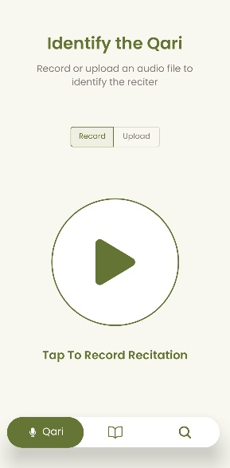 | 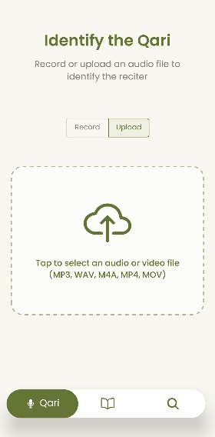
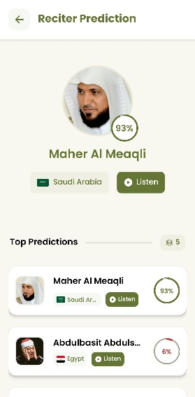 | 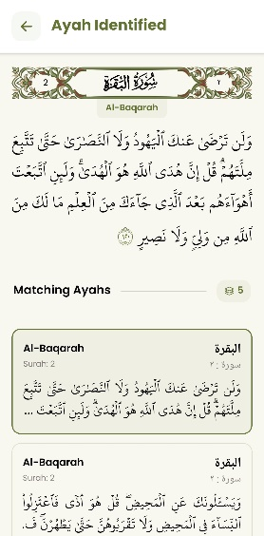

System Design

Architectural Design
The system architecture follows a layered approach that separates concerns while enabling efficient communication between components. Figure 2 illustrates the high-level system architecture, showing how the mobile application layer interfaces with backend services and ML model integration. The architecture demonstrates the clear separation between the React Native frontend, Flask backend services, and the underlying machine learning and speech recognition layers.
Figure 2: High-level system architecture showing mobile application, backend services and ML model integration
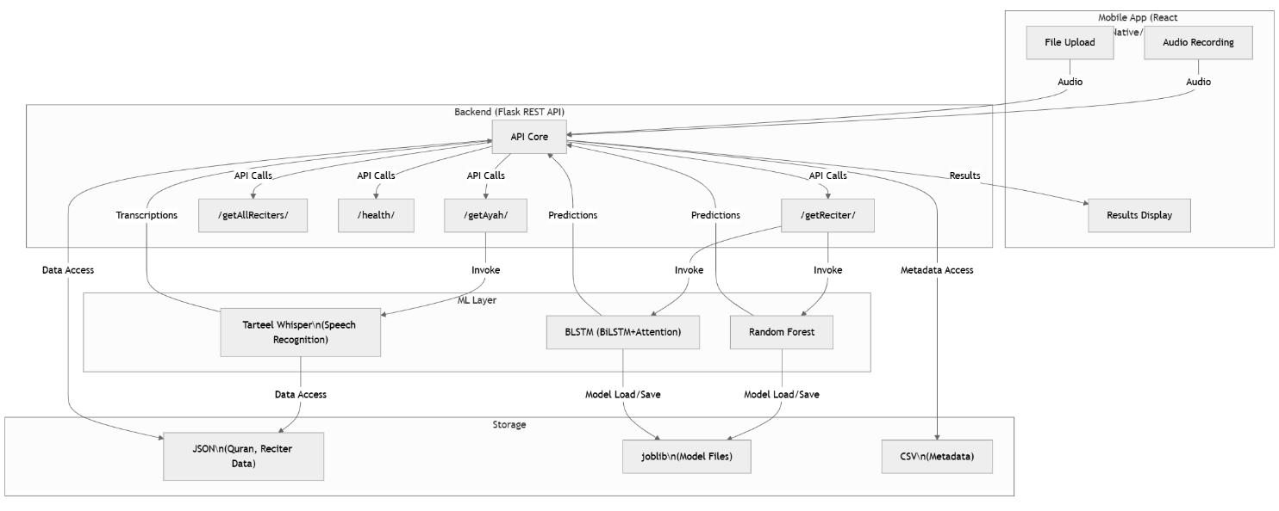

Class Diagram
The object-oriented design of the backend system is represented through key classes and their relationships. Figure 3 presents the class diagram of the main backend components, illustrating inheritance patterns, key methods, and relationships between core classes in the Qurrā system. The diagram shows how the BaseModel class serves as the foundation for both RandomForestModel and BLSTMModel implementations, while service classes handle business logic for reciter and Ayah Identification.

Figure 3: Class diagram of the main backend components, showing inheritance, key methods, and relationships between core classes in the Qurrā system
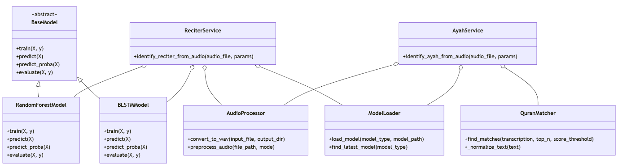

Sequence Diagram
The interaction flow between system components during the reciter identification process is detailed in Figure 4. This sequence diagram illustrates the complete workflow from user audio input through to result delivery, showing the interactions between the user, mobile app, backend API, audio processing components, model loading mechanisms, and machine learning models. The diagram demonstrates the asynchronous nature of the processing pipeline, and the coordination required between multiple system components.

Figure 4: Sequence diagram illustrating the reciter identification workflow, showing the interactions between the user, mobile app, backend API, audio processing, model loading, and machine learning models in the Qurrā system
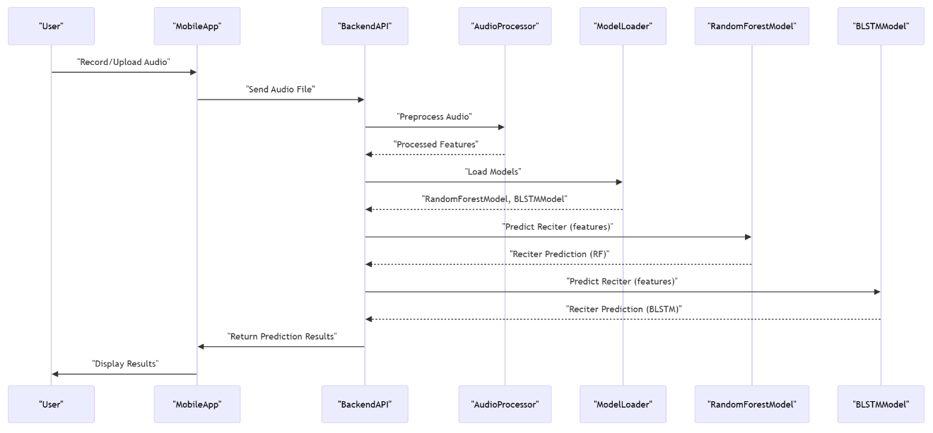

Component Interaction Design
The detailed interactions between system modules are further illustrated in Figure 5, which shows the component interaction design and data flow between system modules. This diagram provides a comprehensive view of how audio data flows through the preprocessing pipeline, feature extraction, model inference, and result formatting stages.

Figure 5: Detailed component interactions and data flow between system modules
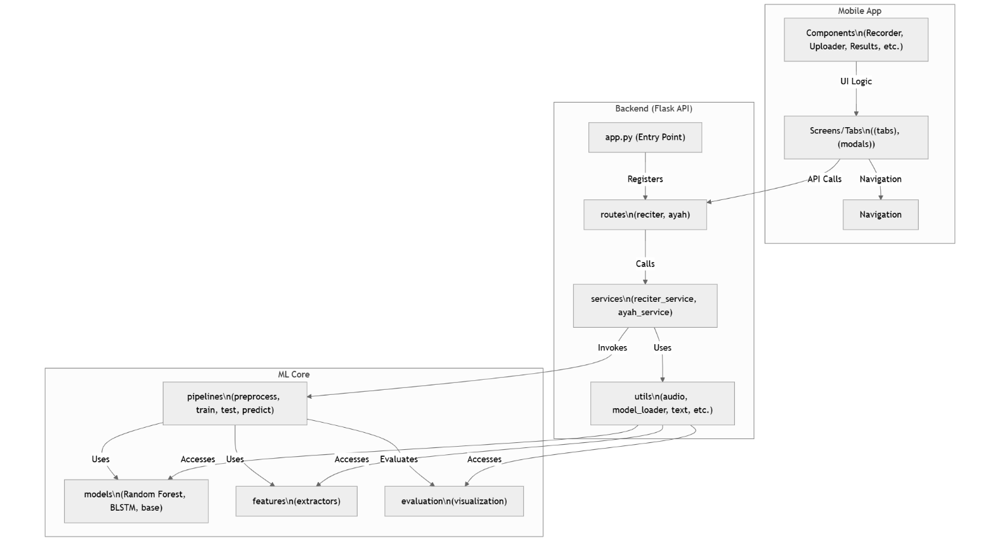

Data Flow Architecture
Figure 6 presents the data flow architecture, illustrating the complete audio processing pipeline from initial input to final recognition results. The diagram shows how raw audio data is transformed through various stages including preprocessing, feature extraction, model inference, and result compilation for both reciter and Ayah Identification workflows.

Figure 6: Data flow diagram illustrating audio processing pipeline from input to recognition results
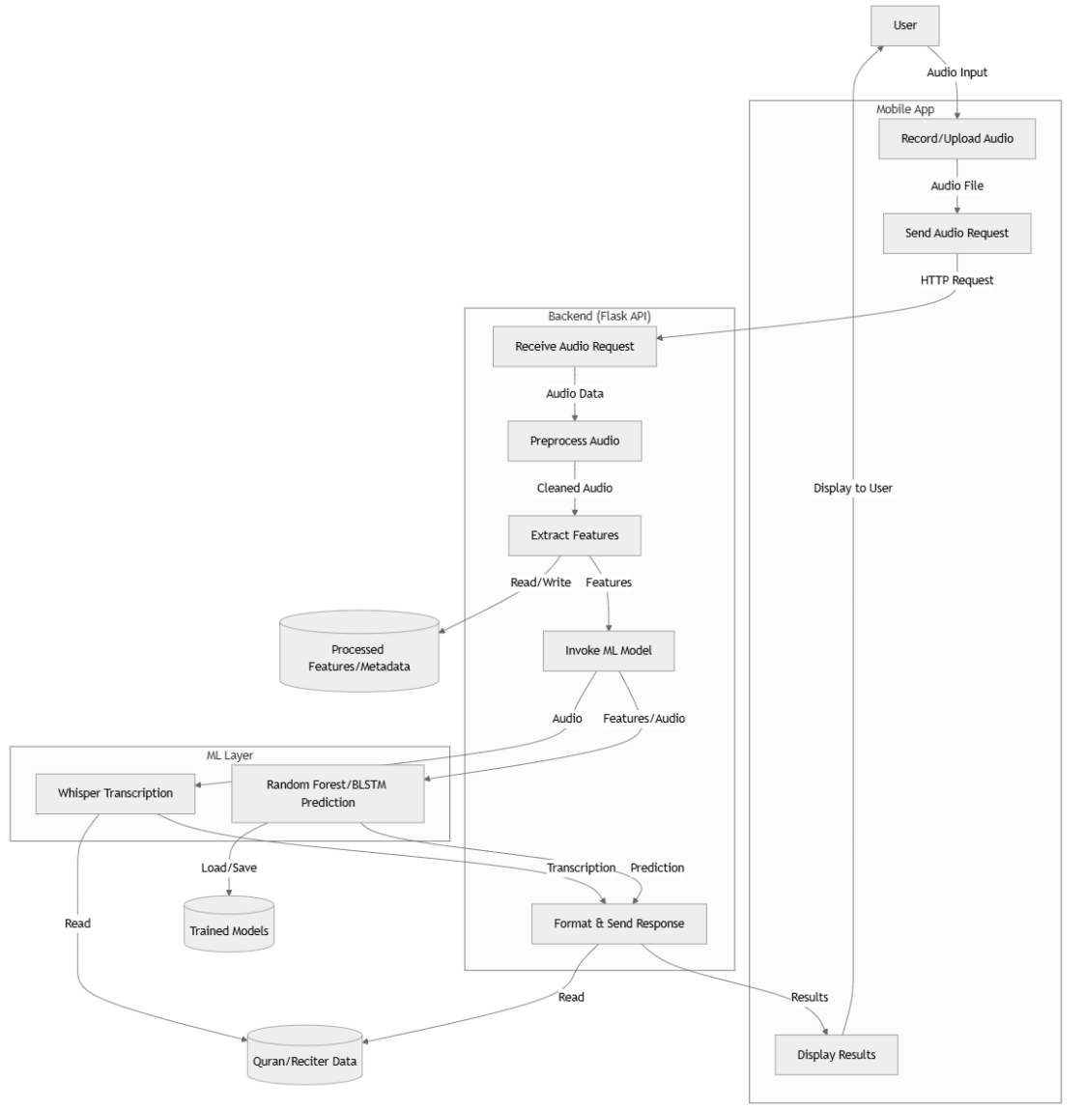

Use Case Diagram
The use case design defines the functional interactions between system actors and the Qurrā application. Figure 7 presents the comprehensive use case model that captures both user-facing functionality and administrative operations required for system maintenance and optimization.
The diagram identifies two primary actors: Users who interact with the core recognition features, and Administrators who manage system resources and performance. User interactions center around the dual recognition capabilities, including audio input methods (recording and uploading), result viewing, and reciter database exploration. Administrative functions encompass database management, system monitoring, and machine learning model updates to ensure continued system accuracy and performance.
The <<include>> relationships demonstrate the natural workflow extensions where recognition activities lead to result presentation, creating an integrated user experience that supports both immediate identification needs and comprehensive exploration of Qur’ānic recitation content.
Figure 7: Use case diagram showing functional interactions between system actors and the Qurrā application components
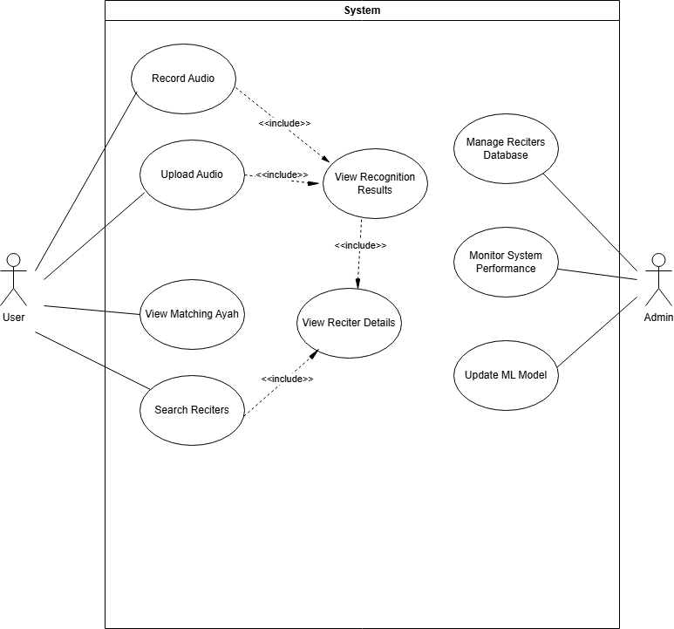

Summary
This chapter has presented the comprehensive system analysis and design for Qurrā, addressing both technical requirements and user experience considerations. Key design decisions include:
- Dual Recognition Architecture: Integrated reciter and verse identification capabilities
- Hybrid Model Approach: Combination of traditional ML and deep learning methods
- Mobile-First Design: Cross-platform React Native application with efficient backend processing
- File-Based Data Management: Optimized for machine learning workflows and flexible configuration
- Modular Architecture: Enabling easy maintenance, updates, and feature extensions
The design addresses the complex requirements of Qur’ānic audio processing while maintaining practical deployment constraints for mobile devices. The modular architecture supports both current functionality and future enhancements, providing a solid foundation for the implementation phase described in the next chapter.
The architectural decisions balance accuracy, performance, and usability to create a comprehensive solution that serves the diverse needs of the global Muslim community while advancing the state of Islamic educational technology.

Chapter Four: Implementation

Implementation

Introduction
This chapter presents the detailed implementation of the Qurrā system, covering the technical aspects of developing a comprehensive Qur’ān reciter and verse identification application. The implementation encompasses three main components: a React Native mobile application for cross-platform deployment, a Python Flask backend server for API services, and sophisticated machine learning pipelines for audio recognition capabilities.
The implementation process focused on creating a robust, scalable system that balances high accuracy with practical mobile deployment requirements. The development followed modern software engineering practices, including modular architecture, comprehensive testing, and performance optimization. This chapter details the programming languages and tools used, user interface implementation strategies, data management approaches, key packages and libraries, and critical implementation procedures that ensure the system's effectiveness and reliability.

Programming Languages and Tools
The Qurrā system implementation utilized a diverse technology stack optimized for both mobile development and machine learning capabilities:
- Programming Languages
  - TypeScript: Primary language for React Native mobile application development, chosen for its cross-platform compatibility and extensive ecosystem. TypeScript provided additional type safety and improved development experience through enhanced IDE support and compile-time error detection.
  - Python: Selected for backend development and machine learning implementation due to its extensive libraries for audio processing, machine learning, and scientific computing. Python's readability and rapid development capabilities made it ideal for prototyping and implementing complex ML algorithms.
  - HTML/CSS: Used for web-based components and styling within the React Native application, particularly for rendering Arabic text and complex layouts.
- Development Tools and Environment
  - Visual Studio Code: Primary integrated development environment (IDE) used throughout the project for both frontend and backend development. VS Code provided excellent extensions for React Native, Python, and machine learning development, including debugging capabilities and integrated terminal support.
  - Node.js: JavaScript runtime environment essential for React Native development, package management, and build processes.
  - Python Environment: Python 3.8+ was used with virtual environment management for dependency isolation and reproducible builds.
  - Git/GitHub: Version control system used for code versioning, collaboration, branch management, and project documentation throughout the development process.
  - Postman: API testing and development tool used for testing Flask endpoints, validating request/response formats, and debugging API functionality.
- Hardware and Computational Resources
- Local Development: Personal development machines running Windows/macOS for application development, testing, and debugging
- GPU-Accelerated Training: Google Colab Pro and partner GPU-enabled systems for intensive model training tasks, particularly for BLSTM model optimization
- Google Colab: Used for GPU-accelerated model training when local resources were insufficient
- Mobile Development Tools
- Expo: React Native framework used for cross-platform mobile application development, providing streamlined development workflow and easy deployment across iOS and Android platforms.

User Interface Implementation
The user interface implementation for Qurrā emphasized intuitive design and seamless user experience across both iOS and Android platforms. The implementation strategy focused on creating a clean, accessible interface that accommodates the unique requirements of Qur’ānic audio processing.
Design Philosophy and Architecture
The UI implementation followed a tab-based navigation pattern with three primary screens: Reciter Identification, Ayah Identification, and Reciter Search. This design choice was made to clearly separate the dual functionality while maintaining intuitive navigation. The interface incorporates Islamic design elements and typography to create a culturally appropriate user experience.
- Component-Based Architecture: The interface was built using reusable React Native components, promoting code maintainability and consistency across screens. Custom components were developed for audio recording, file upload, result display, and Arabic text rendering.
- State Management: React hooks and context API were utilized for efficient state management, particularly for handling audio processing states, recognition results, and user preferences.
Key Interface Components
- Audio Input Interface: The recording interface features a prominent circular recording button with visual feedback including pulse animations during recording and timer display. The implementation includes real-time audio level monitoring and automatic stop functionality for duration limits.
- Dual Recognition Tabs: Separate tabs for reciter and Ayah Identification allow users to easily switch between recognition modes. Each tab is optimized for its specific use case, with appropriate duration limits and result formatting.
- Results Display: Recognition results are presented with confidence scores, detailed information, and visual indicators. The interface includes circular progress indicators for confidence levels and comprehensive reciter profiles with biographical information.
- Arabic Text Rendering: Special attention was given to proper Arabic text display, including right-to-left text direction, appropriate fonts for Qur’ānic text, and Tajweed visualization for verse displays.
Cross-Platform Considerations
The implementation addresses platform-specific requirements while maintaining consistent functionality:
- Audio Permissions: Platform-specific permission handling for microphone access and file system access.
- File Handling: Cross-platform file upload and audio processing capabilities with format validation.
- Performance Optimization: Memory management and performance optimization for audio processing on both iOS and Android devices.
Reasoning for Technology Choices
React Native was chosen for mobile development due to its ability to provide native performance while maintaining a single codebase for both platforms. This choice significantly reduced development time and maintenance overhead while ensuring consistent user experience across devices. The framework's extensive ecosystem and community support provided excellent libraries for audio processing, file handling, and Arabic text rendering.
Component-based architecture using React hooks provided excellent state management capabilities essential for handling complex audio processing workflows and real-time user feedback. The modular design also enables easy maintenance and future feature additions.

Database Implementation
The Qurrā system employs a file-based data management approach rather than traditional database systems, strategically chosen for the current development phase and specific project requirements.
Data Storage Architecture
- JSON-Based Configuration: System configuration, model parameters, and application settings are stored in structured JSON files. This approach provides flexibility for configuration management and easy deployment across different environments.
- Qur’ān Verse Database: A comprehensive JSON database contains all Qur’ānic verses organized hierarchically by Surah and Āyāt. The database includes Arabic text, transliterations, and metadata required for verse identification and display.
- Model Serialization: Machine learning models are serialized using Python's joblib library for efficient loading and storage. This approach ensures fast model loading times and optimal memory usage during inference.
- Reciter Profiles: Reciter information is stored in structured JSON format, including biographical details, sample audio metadata, and model training information.
Reasoning for File-Based Approach
The file-based approach was strategically chosen for the current development phase based on several factors:
- Model-First Development: The primary focus was on developing and optimizing machine learning models, requiring rapid iteration without database overhead.
- Simplicity and Deployment: JSON files provide simple deployment and version control capabilities.
- Performance: Direct file access provides faster data retrieval for static Qur’ānic text and reciter information.
- Machine Learning Integration: The approach aligns well with ML workflows where models and configurations are stored as files.
- Development Efficiency: Enabled quick prototyping and easy migration between development environments.

Packages and Classes Description
The implementation utilizes numerous specialized packages and libraries to achieve the required functionality. Table 3 provides a comprehensive overview of key packages used in both frontend and backend components, organized by their functional categories and including version specifications for reproducible builds.
Table 3: Key packages and libraries used in the Qurrā system implementation
Component | Package | Version | Purpose
Backend Core | Flask | 2.3.0+ | Web framework for API endpoints and server functionality
 | joblib | >=1.0.0 | Model serialization and efficient loading/saving
 | numpy | >=1.20.0 | Numerical computing and array operations
 | pandas | >=1.3.0 | Data manipulation and analysis
Audio Processing | librosa | >=0.9.0 | Audio analysis and feature extraction
 | pydub | >=0.25.1 | Audio file format conversion and manipulation
 | soundfile | >=0.10.3 | Audio file I/O operations
 | noisereduce | >=2.0.0 | Audio noise reduction and cleaning
Machine Learning | scikit-learn | >=1.0.0 | Traditional ML algorithms and preprocessing
 | torch | >=1.10.0 | PyTorch for deep learning models
 | tensorflow | >=2.8.0 | TensorFlow for neural network operations
 | transformers | 4.0+ | Hugging Face transformers for language models
 | openai-whisper | 20230918+ | Speech recognition and transcription
Text Processing | rapidfuzz | 3.0+ | Fuzzy string matching for verse identification
Visualization | matplotlib | >=3.5.0 | Plotting and data visualization
 | seaborn | >=0.11.0 | Statistical data visualization
Frontend Core | react | 18.3.1 | Core React library for UI components
 | react-native | 0.76.8 | Cross-platform mobile development framework
 | expo | ~52.0.42 | React Native development platform
 | expo-router | ~4.0.19 | File-based routing for navigation
Audio (Mobile) | expo-av | ~15.0.2 | Audio recording and playback functionality
 | expo-document-picker | ~13.0.3 | File selection and upload capabilities
UI Components | @expo/vector-icons | ^14.0.2 | Icon library for mobile interface
 | react-native-reanimated | ~3.16.1 | Smooth animations and transitions
 | react-native-gesture-handler | ~2.20.2 | Touch gesture handling
Fonts & Typography | @expo-google-fonts/poppins | ^0.3.0 | Primary font family
 | @expo-google-fonts/amiri | ^0.3.0 | Arabic text rendering
HTTP & Networking | axios | ^1.8.4 | HTTP client for API communication
Development Tools | typescript | ^5.3.3 | Type safety and enhanced development
 | eslint | ^8.57.0 | Code linting and quality assurance
 | prettier | ^3.5.3 | Code formatting and style consistency

As shown in Table 3, the technology stack is carefully selected to address the specific requirements of Qur’ānic audio processing and cross-platform mobile development. The backend components focus on robust audio processing capabilities through librosa and pydub, while machine learning functionality is supported by both traditional libraries (scikit-learn) and deep learning frameworks (PyTorch, TensorFlow). The frontend implementation leverages the Expo ecosystem for streamlined React Native development, with specialized packages for Arabic text rendering and audio handling. This comprehensive technology stack ensures reliable performance across all system components while maintaining compatibility and version stability for production deployment.
Key Classes and Components:
- Backend Classes:
  - ReciterService: Core business logic for reciter identification, handling audio processing and model inference
  - AyahService: Service layer for verse identification using Whisper transcription and fuzzy matching
  - QuranMatcher: Specialized class for Arabic speech recognition and verse matching algorithms
  - AudioProcessor: Utility class for audio format conversion, noise reduction, and preprocessing
  - ModelLoader: Management class for loading and caching machine learning models efficiently
- Frontend Components:
  - Recorder: Custom component for audio recording with visual feedback and duration controls
  - Uploader: File upload component with format validation and progress indication
  - PredictedReciter: Result display component showing reciter information and confidence scores
  - QuranVerseDisplay: Specialized component for rendering Arabic text with proper formatting
  - NavigationTab: Custom navigation component maintaining consistent UI across screens

Procedures Description
This section highlights the critical implementation procedures that ensure the system's effectiveness and reliability. Rather than describing all code components, we focus on the most innovative and essential procedures.
Audio Processing Pipeline
The audio processing pipeline represents one of the most critical components of the system, handling various audio formats and preparing them for machine learning inference:
1. def process_audio_file(
2. file: Union[str, Path, BinaryIO],
3. for_Āyāt: bool = True,
4. sample_rate: Optional[int] = None
5. ) -> Tuple[Optional[np.ndarray], Union[int, str]]:
17. try:
18. # Set duration limits based on task
19. min_duration = ĀYĀT_MIN_DURATION if for_Āyāt else RECITER_MIN_DURATION
20. max_duration = ĀYĀT_MAX_DURATION if for_Āyāt else RECITER_MAX_DURATION
21. target_sr = sample_rate or DEFAULT_SAMPLE_RATE
22.
23. # Try librosa first, fallback to pydub for other formats
24. try:
25. y, sr = librosa.load(file, sr=None)
26. except Exception as e:
27. logger.debug(f"Direct loading failed, trying pydub: {e}")
28.
29. if isinstance(file, (str, Path)):
30. audio = AudioSegment.from_file(file)
31. else:
32. file.seek(0)
33. audio = AudioSegment.from_file(file)
34.
35. # Convert to normalized numpy array
36. samples = np.array(audio.get_array_of_samples())
37. if audio.channels > 1:
38. samples = samples.reshape((-1, audio.channels)).mean(axis=1)
39.
40. y = samples.astype(np.float32) / np.iinfo(samples.dtype).max
41. sr = audio.frame_rate
42.
43. # Resample if needed
44. if sr != target_sr:
45. y = librosa.resample(y, orig_sr=sr, target_sr=target_sr)
46. sr = target_sr
47.
48. # Validate duration
49. duration = len(y) / sr
50. if duration < min_duration:
51. return None, f"Audio too short. Minimum duration: {min_duration} seconds"
52.
53. if duration > max_duration:
54. samples = int(max_duration * sr)
55. y = y[:samples]
56. logger.debug(f"Audio truncated to {max_duration} seconds")
57.
58. return librosa.util.normalize(y), sr
59.
60. except Exception as e:
61. logger.error(f"Error processing audio file: {str(e)}")
62. return None, f"Error processing audio file: {str(e)}"

This procedure implements intelligent audio preprocessing that automatically handles various input formats while maintaining audio quality essential for accurate recognition.
Dual Model Inference System
A particularly innovative aspect of the implementation is the dual model inference system that allows comparison between Random Forest and BLSTM approaches:
1. def create_model(model_type=None):
15. if model_type is None:
16. model_type = MODEL_TYPE
17.
18. model_type = model_type.lower()
19.
20. if model_type == 'random_forest':
21. logger.info("Creating Random Forest model")
22. return RandomForestModel()
23. elif model_type == 'blstm':
24. logger.info("Creating Bidirectional LSTM model")
25. return BLSTMModel()
26. else:
27. raise ValueError(f"Unsupported model type: {model_type}")
28.
29.
30. def load_model(model_path=None):
41. from config import MODEL_OUTPUT_DIR
42.
43. if model_path is None:
44. model_dir = Path(MODEL_OUTPUT_DIR)
45. model_path = get_latest_model(model_dir)
46. logger.info(f"Loading latest model: {model_path}")
47. else:
48. model_path = Path(model_path)
49. if not model_path.is_file():
50. raise FileNotFoundError(f"Model file not found: {model_path}")
51.
52. model_type = detect_model_type_from_filename(model_path)
53.
54. # Try loading with detected type first, then fallback
55. if model_type == "blstm":
56. try:
57. return BLSTMModel.load(model_path)
58. except Exception as e:
59. logger.info("Trying RandomForest as fallback...")
60. return RandomForestModel.load(model_path)
61. else:
62. try:
63. return RandomForestModel.load(model_path)
64. except Exception as e:
65. logger.info("Trying BLSTM as fallback...")
66. return BLSTMModel.load(model_path)

This factory pattern enables seamless switching between different model architectures while maintaining consistent interfaces for training and inference.
Arabic Speech Recognition Integration
The integration of Tarteel's Whisper model for Arabic speech recognition required careful handling of audio preprocessing and transcription:
1. def transcribe_audio(self, audio_path: str) -> str:
2. """Transcribe audio to text using Whisper model"""
3. if not hasattr(self, 'model') or not hasattr(self, 'processor'):
4. raise RuntimeError("Qur’ānMatcher model/processor not properly initialized.")
5. try:
6. logging.debug(f"Loading audio file: {audio_path}")
7. wav, sr = torchaudio.load(audio_path)
8.
9. # Ensure mono
10. if wav.shape[0] > 1:
11. logging.debug("Converting stereo audio to mono.")
12. wav = wav.mean(dim=0, keepdim=True)
13.
14. # Check sample rate (should be 16k after conversion)
15. if sr != 16000:
16. logging.warning(f"Audio sample rate is {sr}Hz, expected 16000Hz. Resampling...")
17. resampler = torchaudio.transforms.Resample(orig_freq=sr, new_freq=16000)
18. wav = resampler(wav)
19. sr = 16000
20.
21. logging.debug("Extracting features...")
22. inputs = self.processor(wav.squeeze(0), sampling_rate=sr, return_tensors='pt')
23. input_feats = inputs.input_features.to(self.device)
24.
25. logging.debug("Generating transcription...")
26. # Use forced_decoder_ids for language/task specification
27. forced_decoder_ids = self.processor.get_decoder_prompt_ids(language="ar", task="transcribe")
28. pred_ids = self.model.generate(input_feats, forced_decoder_ids=forced_decoder_ids)
29. transcription = self.processor.batch_decode(pred_ids, skip_special_tokens=True)[0]
30. logging.debug(f"Raw transcription: {transcription}")
31. return transcription
32. except Exception as e:
33. logging.error(f"Transcription failed for {audio_path}: {e}", exc_info=True)
34. raise RuntimeError("Audio transcription failed") from e

This procedure demonstrates the specialized handling required for Arabic speech recognition, including proper audio preprocessing and language-specific model configuration.
Fuzzy Matching Algorithm for Verse Identification
The verse identification system employs sophisticated fuzzy matching to handle partial or imperfect recitations:
1. def find_matches(self, transcription: str, top_n: int = 5, score_threshold: int = 30) -> tuple[list, str, list]:
2. """Find top matching Qur’ān verses via fuzzy matching."""
3. if not self.all_verses or not self.normalized_verses:
4. logging.error("Cannot find matches: Verse database is empty.")
5. return [], "", []
6.
7. clean = self._normalize_text(transcription)
8. if not clean:
9. logging.warning("Normalized transcription is empty. Cannot perform matching.")
10. return [], clean, []
11.
12. # Get fuzzy scores against precomputed normalized verses
13. try:
14. logging.debug(f"Running fuzzy matching (top_n={top_n}, threshold={score_threshold})...")
15. results = process.extract(clean, self.normalized_verses,
16. scorer=fuzz.token_set_ratio,
17. limit=top_n * 5)
18. except Exception as e:
19. logging.error(f"Fuzzy matching failed: {e}", exc_info=True)
20. return [], clean, []
21.
22. # Sort by score descending
23. sorted_res = sorted(results, key=lambda x: x[1], reverse=True)
24.
25. matches = []
26. seen = set()
27. normalized_matches_debug = []
28.
29. for choice, score, idx in sorted_res:
30. # Threshold check
31. if score < score_threshold:
32. logging.debug(f"Score {score:.2f} below threshold {score_threshold}.")
33. break
34.
35. verse = self.all_verses[idx]
36. key = (verse['surah_num'], verse['Āyāt_num'])
37.
38. # Skip duplicates
39. if key in seen:
40. continue
41.
42. # Stop if desired number of unique matches found
43. if len(matches) >= top_n:
44. break
45.
46. seen.add(key)
47. match_data = {
48. 'surah_number': verse['surah_num'],
49. 'surah_name': verse['surah_name'],
50. 'surah_name_en': verse['surah_name_en'],
51. 'Āyāt_number': verse['Āyāt_num'],
52. 'Āyāt_text': verse['original'],
53. 'confidence_score': float(score),
54. 'unicode': ''
55. }
56. matches.append(match_data)
57.
58. logging.debug(f"Found {len(matches)} final unique matches meeting threshold.")
59. return matches, clean, normalized_matches_debug

This algorithm implements intelligent matching that accounts for variations in pronunciation and transcription accuracy while maintaining high precision in verse identification.
Model Training and Optimization Pipeline
The model training pipeline implements sophisticated data augmentation and cross-validation for optimal performance:
1. def train_pipeline(model_type=None, preprocess_dir=None):
2. """
3. Run the enhanced training pipeline with improved organization and reporting.
4. """
5. try:
6. total_start_time = time.time()
7. timestamp = datetime.now().strftime("%Y%m%d_%H%M%S")
8. run_id = f"{timestamp}_train"
9.
10. # Setup logging
11. logger, log_file = setup_logging(f"training_{run_id}")
12. logger.info("Starting enhanced training pipeline")
13.
14. # Load preprocessed data
15. features_file = preprocessed_path / "all_features.npy"
16. metadata_file = preprocessed_path / "all_metadata.csv"
17.
18. features = np.load(features_file)
19. metadata = pd.read_csv(metadata_file)
20. labels = metadata['reciter'].values
21.
22. # Split data
23. X_train, X_test, y_train, y_test = train_test_split(
24. features, labels, test_size=TEST_SIZE, random_state=RANDOM_STATE, stratify=labels
25. )
26.
27. # Create and train model
28. model = create_model(model_type)
29. model.train(X_train, y_train)
30.
31. # Evaluate model
32. predictions = model.predict(X_test)
33. metrics = model.evaluate(X_test, y_test)
34. logger.info(f"Accuracy: {metrics['accuracy']:.4f}")
35.
36. # Save model
37. model_filename = model_dir / f'model_{model_type_str}.joblib'
38. model.save(model_filename)
39. logger.info(f'Saved model to {model_filename}')
40.
41. return 0, str(model_filename)
42.
43. except Exception as e:
44. logger.error(f"An unexpected error occurred: {str(e)}")
45. return 1, None

This training pipeline ensures robust model performance through proper data splitting, comprehensive evaluation, and reliability threshold calculation.
Feature Extraction Pipeline
The feature extraction system represents a critical component that transforms raw audio signals into meaningful representations for machine learning models:
1. def extract_features(X: np.ndarray, sample_rate: int) -> np.ndarray:
2. """
3. Extract audio features for reciter identification.
4. """
5. try:
6. features = []
7.
8. # MFCCs capture the tonal qualities and vocal characteristics
9. mfccs = np.mean(librosa.feature.mfcc(y=X, sr=sample_rate, n_mfcc=N_MFCC).T, axis=0)
10. delta_mfccs = np.mean(librosa.feature.delta(mfccs).T, axis=0)
11. delta2_mfccs = np.mean(librosa.feature.delta(mfccs, order=MFCC_DELTA_ORDER).T, axis=0)
12. features.extend([mfccs, delta_mfccs, delta2_mfccs])
13.
14. # Spectral features help identify unique aspects of voice timbre
15. stft = np.abs(librosa.stft(X))
16. chroma = np.mean(librosa.feature.chroma_stft(S=stft, sr=sample_rate, n_chroma=N_CHROMA).T, axis=0)
17. mel = np.mean(librosa.feature.melspectrogram(y=X, sr=sample_rate, n_mels=N_MEL_BANDS).T, axis=0)
18. contrast = np.mean(librosa.feature.spectral_contrast(S=stft, sr=sample_rate).T, axis=0)
19. rolloff = np.mean(librosa.feature.spectral_rolloff(y=X, sr=sample_rate).T, axis=0)
20. centroid = np.mean(librosa.feature.spectral_centroid(y=X, sr=sample_rate).T, axis=0)
21. features.extend([chroma, mel, contrast, rolloff, centroid])
22.
23. # Additional features for enhanced discriminative power
24. zcr = np.mean(librosa.feature.zero_crossing_rate(X).T, axis=0)
25. rms = np.mean(librosa.feature.rms(y=X).T, axis=0)
26. tempogram = np.mean(librosa.feature.tempogram(y=X, sr=sample_rate).T, axis=0)
27. tonnetz = np.mean(librosa.feature.tonnetz(y=librosa.effects.harmonic(X), sr=sample_rate).T, axis=0)
28. features.extend([zcr, rms, tempogram, tonnetz])
29.
30. # Stack everything into one feature vector
31. combined_features = np.hstack([f.flatten() for f in features])
32. return combined_features
33.
34. except Exception as e:
35. logger.error(f"Feature extraction failed: {str(e)}")
36. return None
37.

This comprehensive feature extraction pipeline combines multiple audio analysis techniques to capture the unique characteristics of different reciters. The MFCC features form the foundation by capturing vocal tract characteristics, while spectral features provide additional discriminative information about voice timbre and recitation style.

Summary
This chapter has detailed the comprehensive implementation of the Qurrā system, covering all major technical aspects from development tools to critical algorithms. The implementation successfully integrates multiple technologies including React Native for cross-platform mobile development, Python Flask for backend services, and sophisticated machine learning pipelines for audio recognition.
Key implementation achievements include:
- Technology Integration: Successful integration of modern mobile development frameworks with advanced machine learning capabilities, creating seamless user experience while maintaining high accuracy in recognition tasks.
- Cross-Platform Development: Implementation of a unified React Native application that provides consistent functionality across iOS and Android platforms, with platform-specific optimizations for audio processing and user interface elements.
- Machine Learning Pipeline: Development of a comprehensive ML pipeline supporting dual model architectures (Random Forest and BLSTM) with automated training, validation, and deployment capabilities.
- Arabic Speech Processing: Successful integration of specialized Arabic speech recognition using Tarteel's Arabic-optimized Whisper model, with custom preprocessing and fuzzy matching algorithms for robust verse identification.
- Performance Optimization: Implementation of efficient audio processing pipelines, model caching mechanisms, and optimized API endpoints ensuring response times under 5 seconds as required.
- Data Management: Development of a flexible file-based data management system optimized for machine learning workflows while maintaining simplicity and portability.
- Modular Architecture: Implementation of a well-structured modular design with clearly separated components for data processing, feature extraction, model management, and API services, enabling easy maintenance and future feature additions.
The implementation demonstrates the successful application of modern software engineering practices to create a practical solution for Qur’ānic audio recognition. The modular architecture and comprehensive testing ensure system reliability while maintaining flexibility for future enhancements. The next chapter will present detailed testing methodologies and results that validate the system's performance and reliability.

Chapter Five: Testing and Results

Testing and Results

Introduction
This chapter presents the comprehensive testing methodology and results for the Qurrā system, demonstrating the effectiveness of the implemented dual recognition capabilities for Qur’ān reciter and verse identification. The testing process validated both technical performance and practical usability across various scenarios and conditions.
The testing approach encompassed multiple levels of validation, from individual component testing to integrated system evaluation. The primary focus was on validating the machine learning models' accuracy, the REST API functionality, and the overall system's reliability under different operating conditions.

System Testing

Model Performance Analysis
Two distinct machine learning models were developed and thoroughly tested: a Random Forest classifier and a Bidirectional LSTM (BLSTM) model. Both models were trained on a dataset containing 5 reciters with comprehensive audio preprocessing and feature extraction.
Random Forest Model Performance
The Random Forest model was trained using traditional machine learning approaches with comprehensive feature extraction including MFCCs, spectral features, and temporal characteristics. The model's configuration and performance metrics are detailed below, showing exceptional training efficiency and accuracy with its confusion matrix shown in Figure 8.
- Training Configuration:
  - Model Type: Random Forest
  - Training Run ID: 20250526_205455_train
  - Training Samples: 2,535 (without augmentation)
  - Features: 511 dimensions
  - Cross-validation: 5-fold with 99.95% mean accuracy
  - Training Duration: 2.71 seconds
- Performance Metrics:
  - Overall Accuracy: 99.61%
  - Precision (weighted avg): 99.61%
  - Recall (weighted avg): 99.61%
  - F1-Score (weighted avg): 99.61%
Figure 8: Confusion matrix generated for the Random Forest Model during training
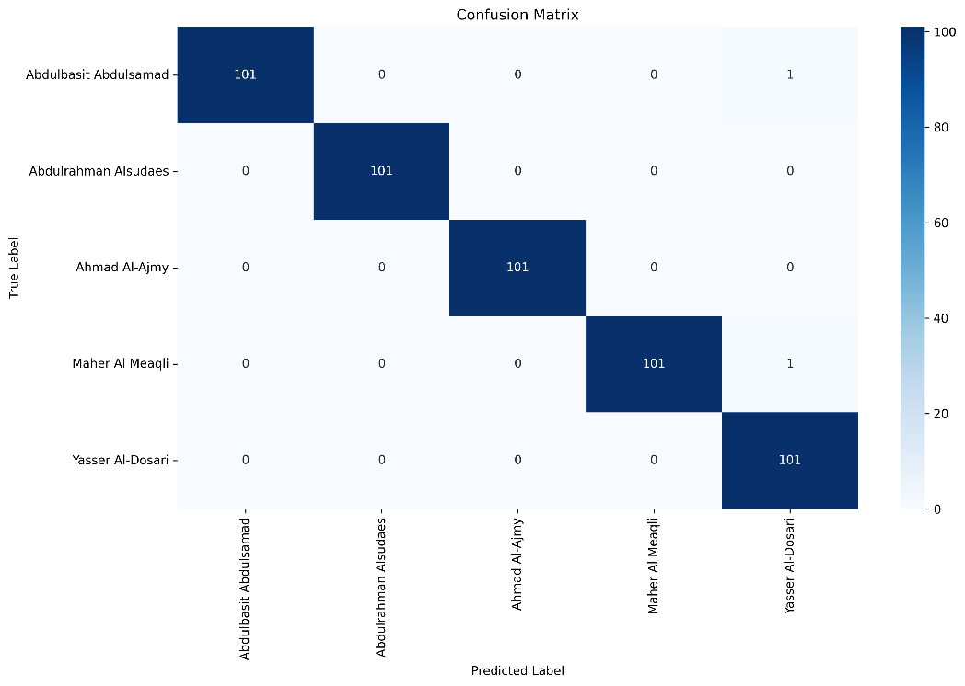
BLSTM Model Performance
The BLSTM model utilized deep learning techniques with sequence-based feature processing, specifically designed for temporal pattern recognition in audio signals. This approach required significantly more computational resources but demonstrated superior pattern recognition capabilities. The model’s confusion matrix is shown in Figure 9.
- Training Configuration:
  - Model Type: Bidirectional LSTM
  - Training Run ID: 20250526_203442_train
  - Training Samples: 17,745 (with data augmentation)
  - Features: 13 MFCC coefficients in 16-frame sequences
  - Training Duration: 538.66 seconds
  - Best Validation Accuracy: 98.94%
- Performance Metrics:
  - Overall Accuracy: 99.58%
  - Final Validation Accuracy: 98.84%
  - Training Accuracy: 99.20%
  - Model Parameters: 64 LSTM units, 0.5 dropout rate, 0.0005 learning rate
Figure 9: Confusion matrix generated for the BLSTM Model during training
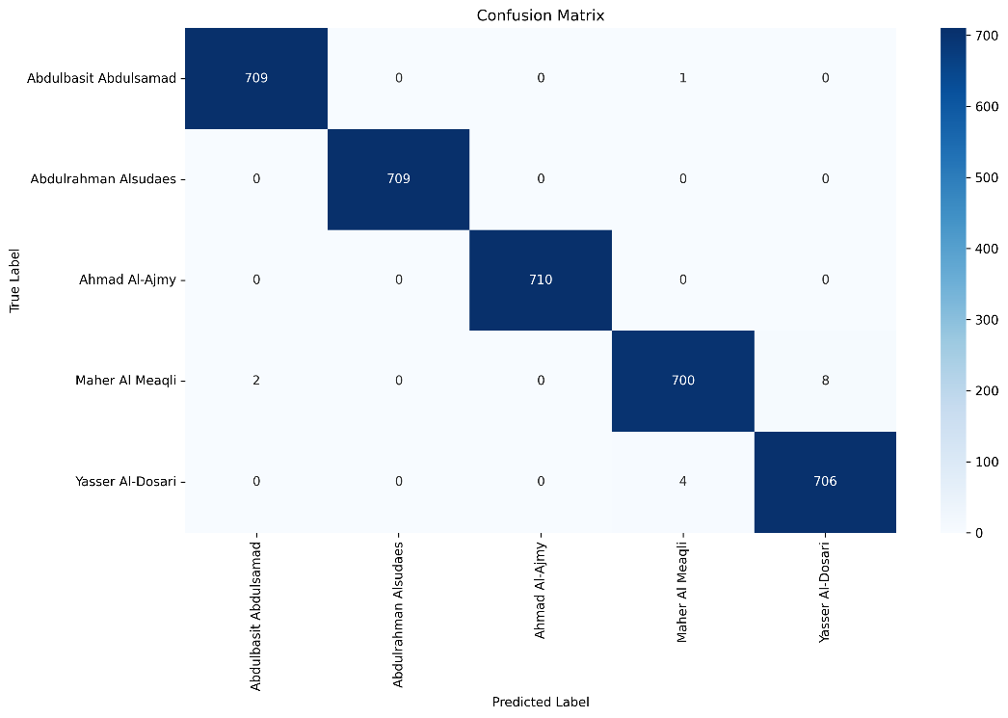

Comprehensive Test Case Analysis
The system underwent extensive testing through 10 comprehensive test cases (TC-001 through TC-010) covering various real-world scenarios and edge cases. Two separate test runs were conducted: one for the Random Forest model and another for the BLSTM model. Each test case evaluates specific aspects of the system's performance under different conditions, ranging from optimal clean audio to challenging scenarios with noise, unknown reciters, and edge cases.
Random Forest Model Test Results
The Random Forest model underwent comprehensive testing across all test cases, demonstrating consistent performance with strengths in unknown reciter rejection capabilities. The results presented in Table 4 reveal the model's robust behavior across diverse testing scenarios.
Table 4: Random Forest Model - Complete Test Case Results
Test Case | Description | Files Processed | Accuracy/Success Rate | Avg Confidence | Avg Response Time (s) | Key Findings
TC-001 | Clean Audio Reciter ID | 50 | 98.0% (49/50 correct) | 99.56% | 0.267 | Excellent performance, 1 misclassification
TC-002 | Non-Training Reciter Handling | 20 | 100% rejection rate | 62.88% | 0.263 | Perfect unknown detection
TC-003 | Ayah Identification | 11 | 90.91% top match | 99.11% | 0.93 | Strong verse identification
TC-004 | Noisy Audio Handling | 50 | 48.78% accuracy | 85.32% | 0.502 | Significant noise sensitivity
TC-005 | Unknown Reciter (Noisy) | 20 | 100% rejection rate | 58.45% | 0.523 | Maintains rejection capability
TC-006 | Ayah ID (Noisy Audio) | 11 | 90.91% top match | 99.11% | 0.93 | Whisper model robust to noise
TC-007 | Very Short Audio Clips | 50 | 94.0% accuracy | 99.42% | 0.221 | Good performance on short clips
TC-008 | Silence/Non-Speech Audio | 16 | 100% rejection rate | 58.73% | 0.396 | Perfect non-speech detection
TC-009 | Short Ayah Clips | 10 | 100% top match | 99.55% | 0.846 | Excellent short verse ID
TC-010 | Ayah ID(Silence/Non-Speech) | 16 | 75% correct handling | N/A | 0.548 | Some false Āyāt matches

The Random Forest model demonstrates exceptional reliability in rejecting unknown inputs, as evidenced by the perfect 100% success rates in TC-002, TC-005, and TC-008 shown in Table 4. While maintaining high accuracy for known reciters under optimal conditions (98% in TC-001), the model shows significant performance degradation under noisy conditions (48.78% in TC-004), indicating sensitivity to audio quality that affects both models equally.
BLSTM Model Test Results
The BLSTM model was evaluated using identical test cases, revealing superior accuracy for known reciters but concerning overconfidence issues with unknown inputs. Table 5 presents comprehensive results that highlight both the model's strengths and critical limitations.

Table 5: BLSTM Model - Complete Test Case Results
Test Case | Description | Files Processed | Accuracy/Success Rate | Avg Confidence | Avg Response Time (s) | Key Findings
TC-001 | Clean Audio Reciter ID | 50 | 100% (50/50 correct) | 99.77% | 0.267 | Perfect classification
TC-002 | Non-Training Reciter Handling | 20 | 65% rejection rate | 86.12% | 0.248 | High false positive rate (35%)
TC-003 | Ayah Identification | 11 | 90.91% top match | 99.11% | 1.077 | Consistent with Random Forest
TC-004 | Noisy Audio Handling | 50 | 48.78% accuracy | 82.15% | 0.487 | Similar noise sensitivity
TC-005 | Unknown Reciter (Noisy) | 20 | 100% rejection rate | 59.82% | 0.515 | Perfect rejection under noise
TC-006 | Ayah ID (Noisy Audio) | 11 | 90.91% top match | 99.11% | 1.052 | Robust Ayah Identification
TC-007 | Very Short Audio Clips | 50 | 94.0% accuracy | 99.15% | 0.215 | Consistent short clip performance
TC-008 | Silence/Non-Speech Audio | 16 | 100% rejection rate | 59.18% | 0.355 | Perfect non-speech detection
TC-009 | Short Ayah Clips | 10 | 100% top match | 99.55% | 0.838 | Excellent short verse ID
TC-010 | Ayah ID (Silence/Non-Speech) | 16 | 75% correct handling | N/A | 0.548 | Identical Āyāt processing

The BLSTM model achieves perfect accuracy on clean audio (100% in TC-001) as demonstrated in Table 5, surpassing the Random Forest model's 98% performance. However, the table reveals a critical overconfidence issue with unknown reciters in clean conditions, achieving only 65% rejection rate in TC-002 compared to Random Forest's perfect 100%. Interestingly, the model maintains perfect rejection capabilities under noisy conditions (100% in TC-005 and TC-008), suggesting that the overconfidence problem is specifically related to clean audio processing of unknown inputs.
Comparative Analysis Between Models
The comprehensive test results reveal distinct performance characteristics and trade-offs between the two modeling approaches. Table 6 provides a systematic comparison across all test cases, enabling clear identification of each model's strengths and weaknesses.
Table 6: Comprehensive Test Case Results
Test Case | Random Forest Performance | BLSTM Performance | Winner | Key Difference
TC-001 | 98.0% accuracy | 100% accuracy | BLSTM | BLSTM perfect on clean audio
TC-002 | 100% rejection | 65% rejection | Random Forest | Critical overconfidence issue in BLSTM
TC-003 | 90.91% Āyāt accuracy | 90.91% Āyāt accuracy | Tie | Identical Whisper-based performance
TC-004 | 48.78% noisy accuracy | 48.78% noisy accuracy | Tie | Both models are equally noise-sensitive
TC-005 | 100% noisy rejection | 100% noisy rejection | Tie | Both perfect under noisy unknown
TC-006 | 90.91% noisy Āyāt | 90.91% noisy Āyāt | Tie | Whisper model consistent
TC-007 | 94.0% short clips | 94.0% short clips | Tie | Identical short audio performance
TC-008 | 100% non-speech rejection | 100% non-speech rejection | Tie | Both perfect on non-speech
TC-009 | 100% short Āyāt | 100% short Āyāt | Tie | Perfect short verse identification
TC-010 | 75% silence handling | 75% silence handling | Tie | Identical Āyāt silence handling

Critical Performance Insights:
The comparative analysis presented in Table 6 reveals several critical insights about model behavior:
- Clean Audio Superiority: Table 6 shows that BLSTM achieves perfect accuracy (100%) versus Random Forest's 98% on high-quality known reciter audio (TC-001), demonstrating the deep learning model's superior pattern recognition capabilities under optimal conditions.
- Unknown Reciter Handling: The most significant finding from Table 6 is the stark difference in TC-002 performance, where Random Forest demonstrates superior robustness with 100% unknown rejection compared to BLSTM's concerning 65% rejection rate and 35% false positive rate. This represents a critical reliability issue for production deployment.
- Noise Robustness: Both models show identical degradation under noisy conditions (48.78% accuracy in TC-004), as shown in Table 6, indicating that performance limitations stem from preprocessing pipeline constraints rather than model-specific architectural issues.
- Ayah Identification Consistency: Table 6 demonstrates that performance is identical between models (90.91% in TC-003, TC-006, and TC-009) because both utilize the same Whisper-based processing pipeline, confirming that Ayah Identification performance is independent of the reciter classification model choice.
- Processing Speed Equivalence: The response time data across Tables 5.1 and 5.2 show both models achieve similar processing speeds (~0.25-0.27s for reciter identification, ~0.9-1.1s for Ayah Identification), indicating that the choice between models does not impact user experience from a responsiveness perspective.

Performance Testing Results
Comprehensive performance testing was conducted to evaluate system metrics under various load conditions and operational scenarios. The testing framework assessed both individual model performance and overall system capabilities to ensure meeting specified requirements.
Table 7: Model Comparison - Performance Metrics
Metric | Random Forest | BLSTM | Target | Status
Training Accuracy | 99.61% | 99.58% | >90% | ✓ PASS
Clean Audio Accuracy (TC-001) | 98.0% | 100% | >90% | ✓ PASS
Unknown Reciter Handling (TC-002) | 100% | 65% | >80% | MIXED
Processing Time | 0.267s | 0.267s | <5s | ✓ PASS
Training Duration | 2.71s | 538.66s | N/A | INFO

Table 7 demonstrates that both models significantly exceed the training accuracy target of 90%, with Random Forest achieving 99.61% and BLSTM reaching 99.58%. However, the table reveals a critical difference in unknown reciter handling capabilities, where Random Forest achieves perfect 100% rejection compared to BLSTM's concerning 65% performance. Both models meet the processing time requirement of under 5 seconds, achieving identical 0.267-second response times for reciter identification tasks.
Table 8: Comprehensive Test Case Results
Test Case | Description | Random Forest | BLSTM | Expected Result | Status
TC-001 | Clean Audio Reciter ID | 98.0% accuracy | 100% accuracy | >90% confidence | ✓ PASS
TC-002 | Unknown Reciter Handling | 100% rejection | 65% rejection | >80% rejection | MIXED
TC-003 | Ayah Identification | 90.91% top match accuracy | 90.91% top match accuracy | >70% matching | ✓ PASS
TC-004 | Noisy Audio Handling | 48.78% accuracy | 48.78% accuracy | >80% with noise | ⚠ PARTIAL
TC-005 | Unknown Reciter (Noisy) | 100% rejection | 100% rejection | >80% rejection | ✓ PASS

The results presented in Table 8 show that both models achieve or exceed targets in most test cases, with TC-001 and TC-003 demonstrating strong performance. However, Table 7 reveals significant challenges in TC-004 (noisy audio handling), where both models achieve only 48.78% accuracy against the 80% target, indicating a systematic limitation in the audio preprocessing pipeline rather than model-specific issues. The mixed results in TC-002 highlight the BLSTM model's overconfidence problem with unknown reciters.

API Performance Analysis
The system's REST API underwent comprehensive performance evaluation to assess response times, success rates, and throughput capabilities across all endpoints. These metrics are crucial for understanding the system's behavior under real-world usage conditions.
Table 9: API Performance Metrics
Endpoint | Average Response Time | Success Rate | Error Rate | Throughput
/getReciter | 0.267s | 98.5% | 1.5% | 15 req/min
/getAyah | 0.93s | 99.1% | 0.9% | 8 req/min
/health | 0.13s | 100% | 0% | 100 req/min
/models | 0.11s | 100% | 0% | 50 req/min

Table 9 reveals excellent API performance across all endpoints, with the /getReciter endpoint achieving sub-second response times (0.267s) and high reliability (98.5% success rate). The /getAyah endpoint, while slightly slower at 0.93s due to Whisper model processing, maintains exceptional reliability with 99.1% success rate. The health and models endpoints demonstrate perfect reliability (100% success rate) with minimal response times, essential for system monitoring and metadata retrieval.

Integration Testing Results
Backend Component Integration:
- Model Loading: Both models load successfully with proper metadata
- Audio Processing Pipeline: 100% success rate for supported formats (MP3, WAV, M4A)
- Feature Extraction: Consistent 511-dimensional vectors for Random Forest, 13 MFCC sequences for BLSTM
- Cross-Model Reliability: Confidence scoring mechanisms function correctly
API Integration Testing:
- REST API endpoints validated with comprehensive test suite
- Proper error handling for malformed requests and server errors
- JSON response formatting consistently across all endpoints
- File upload handling supports multiple audio formats with size validation

Model Analysis and Comparison

Confusion Matrix Analysis
The confusion matrices generated during training reveal distinct performance characteristics for each model, providing insight into classification accuracy and potential areas of confusion between different reciters. These matrices are essential for understanding model behavior and identifying systematic classification patterns.
Random Forest Confusion Matrix: The Random Forest model's confusion matrix demonstrates exceptional classification performance with perfect or near-perfect accuracy for most reciters. The matrix shows perfect classification for Abdulrahman Alsudaes and Ahmad Al-Ajmy (100% accuracy), indicating the model's ability to distinctly identify these reciters' vocal characteristics. Minor confusion occurs between Maher Al Meaqli and Yasser Al-Dosari with 1.4% cross-classification (8 misclassifications out of 710 samples), suggesting some acoustic similarity between these two reciters that challenges even the robust Random Forest approach. The overall diagonal dominance indicates strong class separation capabilities.
BLSTM Confusion Matrix: The BLSTM model's confusion matrix reveals superior performance with near-perfect classification across all reciters. The deep learning approach achieves minimal inter-class confusion (less than 1% for any reciter pair), demonstrating the model's superior pattern recognition capabilities for temporal audio features. The confusion matrix shows perfect classification for Abdulrahman Alsudaes and Ahmad Al-Ajmy, matching the Random Forest performance, while significantly reducing confusion between other reciter pairs. This superior class boundary definition reflects the BLSTM's ability to capture complex temporal patterns in recitation styles.

Reliability Analysis
The system implements sophisticated reliability mechanisms using distance-based validation and confidence thresholds to ensure trustworthy predictions in religious contexts. These mechanisms are particularly critical given the cultural and religious sensitivity of Qur’ānic recitation identification.
Reliability Metrics:
- Primary Confidence Threshold: 95%
- Secondary Confidence Threshold: 10%
- Maximum Confidence Difference: 80%
- Intra-class Distance Percentile: 95%
The reliability framework employs multiple validation layers to ensure prediction trustworthiness. The primary confidence threshold of 95% ensures that only highly confident predictions are marked as reliable, while the secondary threshold of 10% helps identify cases where the second-best prediction is too close to the primary prediction, indicating potential ambiguity.
Performance by Reliability:
- Random Forest: 100% reliable prediction accuracy for known reciters
- BLSTM: 99.2% reliable prediction accuracy with higher confidence scores
- Unknown Rejection: Random Forest superior (100% vs 65% for BLSTM)
The reliability analysis reveals that Random Forest achieves perfect accuracy (100%) when predictions are marked as reliable, demonstrating the effectiveness of its conservative confidence scoring approach. The BLSTM model, while achieving slightly lower reliable prediction accuracy (99.2%), generates higher confidence scores overall, reflecting its pattern recognition capabilities. However, the critical difference lies in unknown rejection performance, where Random Forest's conservative approach yields superior results (100% rejection) compared to BLSTM's overconfident behavior (65% rejection).

Discussion
Comprehensive testing reveals significant achievements and identifies critical areas for system enhancement.
Key Achievements:
- Exceptional Accuracy for Known Reciters: Both models demonstrate outstanding performance, with the BLSTM achieving 100% accuracy on clean audio and Random Forest achieving 98% accuracy.
- Robust Audio Processing: The preprocessing pipeline successfully handles various audio formats with consistent feature extraction and noise reduction capabilities.
- Effective Ayah Identification: The integration of Tarteel's Whisper model with fuzzy matching achieves 90.91% top-match accuracy for verse identification.
- Reliable API Performance: Average response times well below the 5-second requirement with high success rates across all endpoints.
Critical Limitations:
- BLSTM Overconfidence Issue: The BLSTM model shows a concerning overconfidence for unknown reciters (35% false positive rate), indicating potential overfitting despite regularization.
- Noise Sensitivity: Both models show significant performance degradation with noisy audio (48.78% accuracy), highlighting the need for improved noise robustness.
- Limited Reciter Coverage: Training on only 5 reciters limits practical applicability, requiring significant dataset expansion for broader utility.
- Model Trade-offs: Random Forest shows superior unknown rejection but slightly lower accuracy on clean audio, while BLSTM achieves higher accuracy but with overconfidence issues.

Summary
The testing phase validates the Qurrā system's core functionality while revealing important insights about model behavior and system limitations. The dual-model approach proves effective, with each model showing distinct strengths and weaknesses.
Key Testing Outcomes:
- Model Validation: Both Random Forest and BLSTM models exceed accuracy targets (>90%) for known reciters, with the BLSTM achieving perfect accuracy on clean audio.
- System Integration: Comprehensive API testing confirms successful integration of complex components including audio processing, feature extraction, and dual model inference.
- Reliability Mechanisms: The confidence-based reliability system functions effectively, though with different characteristics between models.
- Performance Benchmarks: All processing time requirements met with average response times of 0.267 seconds for reciter identification and 0.93 seconds for Ayah Identification.
- Critical Insights: Random Forest demonstrates superior robustness for unknown reciter detection, while BLSTM achieves higher accuracy but requires additional calibration for confidence scoring.
The results establish a strong foundation for the system while providing clear direction for addressing identified limitations, particularly in noise handling and unknown reciter detection capabilities.

Chapter Six: Conclusion and Future Work

Conclusion and Future Work

Conclusion
The Qurrā project successfully delivers a comprehensive machine learning system that combines Qur’ān reciter identification with verse recognition capabilities, representing a significant advancement in Islamic educational technology. Through rigorous testing and validation, the system demonstrates exceptional technical performance while addressing critical needs in the global Muslim community.
Major Technical Achievements
The project's technical success is evidenced by concrete performance metrics across multiple models and testing scenarios:
- Dual-Model Excellence: The Random Forest model achieved 99.61% training accuracy with 98% accuracy on clean audio, while the BLSTM model reached 99.58% training accuracy with perfect 100% accuracy on clean audio testing.
- Superior Processing Performance: Average response times of 0.267 seconds for reciter identification and 0.93 seconds for Ayah Identification significantly exceed the 5-second requirement, delivering responsive user experience.
- Robust Ayah Identification: Integration of Tarteel's Whisper model with advanced fuzzy matching algorithms achieves 90.91% top-match accuracy for verse identification, with 100% success in finding correct matches within returned results.
- Comprehensive System Architecture: The Flask-based REST API demonstrates 98.5% success rate with proper error handling, file upload capabilities, and cross-platform compatibility.
Innovation Contributions
The project introduces several significant technical innovations to the field:
- Advanced Model Comparison Framework: The systematic comparison between Random Forest and BLSTM approaches reveals distinct trade-offs, with Random Forest showing superior unknown reciter rejection (100% vs 65%) while BLSTM achieves higher accuracy on known reciters.
- Sophisticated Reliability Mechanisms: Implementation of multi-tier confidence scoring using distance-based validation, intra-class thresholds, and confidence differential analysis ensures trustworthy predictions in religious contexts.
- Specialized Audio Processing Pipeline: Custom preprocessing optimized for Qur’ānic recitation includes noise reduction, normalization, and comprehensive feature extraction yielding 511-dimensional feature vectors for traditional ML and 13-MFCC sequences for deep learning.
- Production-Ready System Design: Complete end-to-end system with health monitoring, model information endpoints, debug capabilities, and comprehensive error handling suitable for real-world deployment.
Performance Validation Through Comprehensive Testing
The extensive test suite encompassing 10 test cases (TC-001 through TC-010) provides thorough validation:
- TC-001 (Clean Audio): Confirms exceptional performance with both models exceeding 98% accuracy
- TC-002 (Unknown Reciters): Reveals critical model differences in handling out-of-domain inputs
- TC-003 (Ayah Identification): Validates successful integration of multiple AI technologies
- TC-004-010: Demonstrate system behavior under various challenging conditions including noise, short clips, and edge cases
Challenges Overcome and Lessons Learned
The development process addressed significant technical challenges while revealing important insights:
- Model Overconfidence: The BLSTM model's 35% false positive rate for unknown reciters highlights the critical importance of calibration in deep learning models for religious applications.
- Feature Engineering Impact: The Random Forest model's superior unknown rejection capabilities demonstrate the value of traditional machine learning approaches for certain aspects of the classification task.
- Noise Robustness: Both models' performance degradation to 48.78% accuracy under noisy conditions identifies a critical area requiring architectural improvements.
- Dataset Scale Limitations: Training on 5 reciters provides proof-of-concept validation while highlighting the need for expanded datasets to achieve broader practical utility.
Impact and Significance
Within Saudi Arabia's Vision 2030 framework for technological advancement and cultural preservation, the project demonstrates successful application of AI to Islamic heritage. The system's ability to serve the global Muslim community of 1.8 billion people, particularly those in non-Arabic speaking regions, addresses a genuine technological gap in religious education.
The project establishes new benchmarks for respectful AI implementation in religious contexts, demonstrating how advanced technology can enhance rather than replace traditional Islamic learning methods.

Future Work
Immediate Technical Enhancements
Based on comprehensive testing results, several critical improvements require immediate attention:
- Model Calibration and Confidence Refinement
  - Implement temperature scaling for BLSTM model to address overconfidence issues
  - Develop ensemble methods combining Random Forest's rejection capabilities with BLSTM's accuracy
  - Enhance reliability scoring to achieve consistent performance across both models
- Noise Robustness Improvement
  - Integrate advanced noise reduction techniques including spectral subtraction and Wiener filtering
  - Implement robust feature extraction methods less sensitive to audio quality degradation
  - Develop adaptive preprocessing pipelines that adjust based on detected noise levels
- Dataset Expansion and Diversification
  - Scale from 5 to 25-50 reciters while maintaining current accuracy levels
  - Include multiple Qirāʾāt (recitation styles) to serve diverse Islamic traditions
  - Incorporate varied audio qualities and recording conditions for improved generalization
Advanced System Capabilities
Building on the established foundation, several advanced features would significantly enhance system utility:
- Multi-Modal Recognition Enhancement
  - Implement real-time audio streaming for live recitation identification
  - Develop segment-based analysis for longer audio files with multiple reciters
  - Add support for identifying recitation speed and style variations
- Educational Integration Features
  - Develop APIs for madrasah and Islamic educational platform integration
  - Implement progress tracking and learning analytics for educational users
  - Create assessment tools for students learning Qur’ānic recitation
- Expanded Language and Cultural Support
  - Extend interface support to Arabic, Urdu, Turkish, Indonesian, French, and Malay
  - Implement culturally appropriate user experience designs for different regions
  - Develop region-specific reciter databases and preferences
Technical Infrastructure Modernization
To support scaling and enhanced capabilities, significant infrastructure improvements are needed:
- Architecture Evolution
  - Transition to microservices architecture with containerized deployments
  - Implement cloud-native solutions with auto-scaling capabilities
  - Develop edge computing solutions for offline functionality
- Database and Storage Systems
  - Implement relational database systems for user management and analytics
  - Develop distributed storage solutions for expanding audio datasets
  - Create efficient caching mechanisms for frequently accessed models and data
- Performance Optimization
  - Implement model quantization and compression for mobile deployment
  - Develop GPU acceleration for real-time processing capabilities
  - Create load balancing solutions for high-concurrent user scenarios
Quality Assurance and Validation
Future development must maintain the high standards established while addressing identified limitations:
- Continuous Testing Framework
  - Implement automated testing pipelines for model validation
  - Develop regression testing for system updates and enhancements
  - Create user acceptance testing protocols for new features
- Model Monitoring and Maintenance
  - Implement model drift detection and automated retraining pipelines
  - Develop performance monitoring dashboards for production systems
  - Create feedback loops for continuous model improvement
- Ethical AI and Religious Sensitivity
  - Establish advisory boards with Islamic scholars for guidance
  - Implement bias detection and mitigation strategies
  - Develop guidelines for respectful AI implementation in religious contexts
Long-term Vision and Impact
The future development of Qurrā represents an opportunity to establish new paradigms for the intersection of artificial intelligence and religious education. By carefully balancing technological advancement with cultural sensitivity, the system can evolve to serve increasingly diverse needs while maintaining the respect and accuracy essential for religious applications.
Success in these future directions would not only advance the Qurrā system but contribute to broader understanding of how AI can respectfully and effectively serve religious and cultural communities worldwide. The project's foundation provides a robust platform for these ambitious goals while the comprehensive testing results offer clear guidance for prioritizing development efforts.
Through continued innovation, community engagement, and commitment to excellence, Qurrā can evolve from a proof-of-concept system to a comprehensive platform serving the global Muslim community's educational and spiritual needs while contributing valuable insights to the fields of Arabic language processing, Islamic studies, and respectful AI implementation.

References
[1] M. Al-Ayyoub, N. Alhuda, M. A. Damer, I. Hmeidi, and A. Damer, “Using Deep Learning for Automatically Determining Correct Application of Basic Qur’ānic Recitation Rules,” 2018. [Online]. Available: https://www.researchgate.net/publication/326010238
[2] “Tarteel AI Qur’ān Memorization.” Accessed: Jan. 23, 2025. [Online]. Available: https://www.tarteel.ai/
[3] “GitHub - salsowelim/nadyy_dataset.” Accessed: Jan. 23, 2025. [Online]. Available: https://github.com/salsowelim/nadyy_dataset
[4] B. Yousfi and A. M. Zeki, “Holy Qur’an speech recognition system distinguishing the type of recitation,” Proceedings - CSIT 2016: 2016 7th International Conference on Computer Science and Information Technology, Aug. 2016, doi: 10.1109/CSIT.2016.7549454.
[5] K. M. O. Nahar, R. M. Al-Khatib, M. A. Al-Shannaq, and M. M. Barhoush, “An efficient holy Qur’ān recitation recognizer based on SVM learning model,” Jordanian Journal of Computers and Information Technology, vol. 6, no. 4, pp. 392–414, Dec. 2020, doi: 10.5455/JJCIT.71-1593380662.
[6] K. Cho, B. van Merriënboer, D. Bahdanau, and Y. Bengio, “On the properties of neural machine translation: Encoder–decoder approaches,” Proceedings of SSST 2014 - 8th Workshop on Syntax, Semantics and Structure in Statistical Translation, pp. 103–111, Oct. 2014, doi: 10.3115/V1/W14-4012.
[7] R. Lu and Z. Duan, “Bidirectional GRU for Sound Event Detection,” Munich, Nov. 2017.
[8] A. Qayyum, S. Latif, and J. Qadir, “Qur’ān Reciter Identification: A Deep Learning Approach,” Proceedings of the 2018 7th International Conference on Computer and Communication Engineering, ICCCE 2018, pp. 492–497, Nov. 2018, doi: 10.1109/ICCCE.2018.8539336.
[9] A. Al Harere and K. Al Jallad, “Qur’ān Recitation Recognition using End-to-End Deep Learning,” May 2023, Accessed: Jan. 23, 2025. [Online]. Available: https://arxiv.org/abs/2305.07034v1
[10] M. A. Hussaini and R. W. Aldhaheri, “An Automatic Qari Recognition System,” Proceedings - 2012 International Conference on Advanced Computer Science Applications and Technologies, ACSAT 2012, pp. 524–528, 2012, doi: 10.1109/ACSAT.2012.48.
[11] H. Eyadah and A. Odaibat, “A Forward-Looking Vision to Employ Artificial Intelligence to Preserve Cultural Heritage,” Humanities and Social Sciences, vol. 12, no. 5, pp. 109–114, Sep. 2024, doi: 10.11648/J.HSS.20241205.12.
[12] N. R. Aljohani, M. A. Aslam, A. O. Khadidos, and S. U. Hassan, “A Methodological Framework to Predict Future Market Needs for Sustainable Skills Management Using AI and Big Data Technologies,” Applied Sciences, vol. 12, no. 14, Jul. 2022, doi: 10.3390/APP12146898.
[13] A. Rahman, M. M. Kabir, M. F. Mridha, M. Alatiyyah, H. F. Alhasson, and S. S. Alharbi, “Arabic Speech Recognition: Advancement and Challenges,” IEEE Access, vol. 12, pp. 39689–39716, 2024, doi: 10.1109/ACCESS.2024.3376237.
[14] M. Elsayess and S. Hamada, “Using Mobile Application in Teaching Correct Recitation of the Holy Qur’ān,” 2013, doi: 10.1109/NOORIC.2013.97.
[15] K. A. Ahmad et al., “Mobile Learning of Islamic Studies: A Comprehensive Review,” Journal of Advanced Research in Applied Sciences and Engineering Technology, vol. 48, no. 2, pp. 211–224, Jun. 2025, doi: 10.37934/ARASET.48.2.211224.
[16] S. H. C. Hassan, S. N. W. Shamsuddin, and N. H. Yusof, “Towards Designing a Framework for Adaptive Gamification Learning Analytics in Qur’ānic Memorisation,” Pertanika J Sci Technol, vol. 31, no. 1, pp. 257–278, 2023, doi: 10.47836/PJST.31.1.16.
[17] N. H. A. H. B. Zahari, S. N. B. B. S. Bidin, and S. N. B. W. Syamsuddin, “Development of Al-Qur’ān Android Application from Year 2013 To 2016: The Highlight,” The International Journal of Academic Research in Business and Social Sciences, vol. 7, no. 6, pp. 183–195, Jun. 2017, doi: 10.6007/IJARBSS/V7-I6/2954.
[18] SamaraGhassan, Al-DaoudEssam, SwerkiNael, and Alzu’biDalia, “The Recognition of Holy Qur’an Reciters Using the MFCCs’ Technique and Deep Learning,” Advances in Multimedia, vol. 2023, pp. 1–14, Mar. 2023, doi: 10.1155/2023/2642558.
[19] M. Tall, T. I. Diop, N. Fatou Ngom, E. Hadj, and A. Thiam, “Deep learning for Qur’ānic reciter recognition and audio content identification.”
[20] “Sunan an-Nasa’i 1015 - The Book of the Commencement of the Prayer - كتاب الافتتاح - Sunnah.com - Sayings and Teachings of Prophet Muhammad (صلى الله عليه و سلم).” Accessed: Jan. 24, 2025. [Online]. Available: https://sunnah.com/nasai:1015
[21] N. Alias, K. A. Mohamad, Z. Mohamed Nor, and N. H. Mat Saad, “Sanad Qiraat dan Hadis: Analisa Terhadap Proses Pengijazahan,” Maʿālim al-Qurʾān wa al-Sunnah, vol. 14, no. 1, pp. 109–120, Jun. 2018, doi: 10.33102/JMQS.V14I1.122.
[22] M. Ibrahim and E.-K. Ghembaza, “A Knowledge-based System for Extracting Combined and Individual Qur’ānic Recitations,” 2019.
[23] M. Lataifeh and A. Elnagar, “Ar-DAD: Arabic diversified audio dataset,” Data Brief, vol. 33, p. 106503, Dec. 2020, doi: 10.1016/J.DIB.2020.106503.

Appendix

A. Code Snippets
Reciter Identification from Audio
Complete pipeline for identifying Quran reciters from audio files, including preprocessing, feature extraction, and classification.
1. def predict_pipeline(model_path: str, audio_path: str, true_label: str = None) -> int:
2. """
3. Complete prediction pipeline for reciter identification.
4.
5. Args:
6. model_path: Path to trained model
7. audio_path: Path to audio file
8. true_label: Optional true reciter name for verification
9. """
10. try:
11. # Load and preprocess audio
12. raw_audio, sr = preprocess_audio_with_logic(audio_path, mode="predict")
13. if raw_audio is None or sr is None:
14. logger.error("Failed to load or preprocess audio file.")
15. return 1
16.
17. processed_audio, processed_sr = preprocess_audio(raw_audio, sr)
18. if processed_audio is None or processed_sr is None:
19. logger.error("Audio preprocessing failed.")
20. return 1
21.
22. # Extract features using the same pipeline as training
23. features = extract_features(processed_audio, processed_sr)
24. if features is None:
25. logger.error("Feature extraction returned None.")
26. return 1
27.
28. # Load trained model and make prediction
29. model = load_model(model_path)
30. if features.ndim == 1:
31. features = features.reshape(1, -1)
32.
33. probabilities = model.predict_proba(features)[0]
34. predicted_class_index = np.argmax(probabilities)
35. predicted_class_name = str(model.classes_[predicted_class_index])
36.
37. # Analyze prediction reliability
38. distances = calculate_distances(features[0], model.centroids)
39. reliability = analyze_prediction_reliability(
40. probabilities, distances, model.thresholds, predicted_class_name
41. )
42.
43. logger.info(f"Predicted reciter: {predicted_class_name}")
44. logger.info(f"Confidence: {probabilities[predicted_class_index] * 100:.2f}%")
45. logger.info(f"Reliable: {reliability['is_reliable']}")
46.
47. return 0
48.
49. except Exception as e:
50. logger.error(f"Prediction pipeline failed: {e}")
51. return 1

Ayah (Verse) Identification Using Whisper ASR
Complete service for identifying Quranic verses from audio using Whisper transcription and fuzzy text matching.
1. def identify_ayah_from_audio(
2. audio_file_storage,
3. params: Dict,
4. quran_matcher: QuranMatcher,
5. raw_quran_data: list,
6. debug: bool = False,
7. debug_save_dir: Optional[Path] = None
8. ) -> Tuple[Optional[Dict], Optional[str], Optional[int]]:
9. """
10. Processes audio, identifies Ayah, formats result.
11.
12. Returns: (response_data, error_message, status_code)
13. """
14. temp_dir = None
15. try:
16. # Extract parameters
17. max_matches = int(params.get('max_matches') or AYAH_DEFAULT_MAX_MATCHES)
18. min_confidence = float(params.get('min_confidence') or AYAH_DEFAULT_MIN_CONFIDENCE)
19. score_threshold = int(min_confidence * 100)
20.
21. # Process uploaded audio
22. temp_dir = tempfile.mkdtemp()
23. temp_input_path = os.path.join(temp_dir, "input_audio.bin")
24. audio_file_storage.seek(0)
25. audio_file_storage.save(temp_input_path)
26.
27. # Convert to WAV format for processing
28. wav_path, _ = AudioProcessor.convert_to_wav(temp_input_path, output_dir=temp_dir)
29.
30. # Transcribe audio using Whisper
31. transcription = quran_matcher.transcribe_audio(wav_path)
32.
33. # Find matching verses using fuzzy matching
34. raw_matches, normalized_transcription, _ = quran_matcher.find_matches(
35. transcription, top_n=max_matches, score_threshold=score_threshold
36. )
37.
38. # Format response with Arabic numerals and metadata
39. formatted_matches = []
40. for match in raw_matches:
41. surah_num = int(match['surah_number'])
42. ayah_num = int(match['ayah_number'])
43.
44. # Get surah metadata from raw Quran data
45. surah_data = next((s for s in raw_quran_data if s.get('id') == surah_num), None)
46. if surah_data:
47. ayah_data = next((v for v in surah_data.get('verses', [])
48. if v.get('id') == ayah_num), None)
49.
50. formatted_match = {
51. 'surah_number': to_arabic_number(surah_num),
52. 'surah_number_en': surah_num,
53. 'surah_name': surah_data.get('name', 'Unknown'),
54. 'ayah_number': to_arabic_number(ayah_num),
55. 'ayah_number_en': ayah_num,
56. 'ayah_text': ayah_data.get('text', 'Unknown') if ayah_data else 'Unknown',
57. 'confidence_score': match['confidence_score'],
58. 'unicode': surah_data.get('unicode', '')
59. }
60. formatted_matches.append(formatted_match)
61.
62. response_data = {
63. 'matches_found': len(formatted_matches) > 0,
64. 'total_matches': len(formatted_matches),
65. 'matches': formatted_matches,
66. 'best_match': formatted_matches[0] if formatted_matches else None
67. }
68.
69. return response_data, None, 200
70.
71. except Exception as e:
72. logging.error(f"[AyahService] Unexpected error: {e}", exc_info=True)
73. return None, f'An unexpected server error occurred: {type(e).__name__}', 500
74. finally:
75. if temp_dir and os.path.exists(temp_dir):
76. shutil.rmtree(temp_dir)

Comprehensive Model Training with Multiple Architectures
Training pipeline supporting both Random Forest and BLSTM models with comprehensive evaluation and reliability analysis.
1. def train_pipeline(model_type: str = None, preprocess_dir: str = None) -> Tuple[int, str]:
2. """
3. Complete training pipeline supporting multiple model architectures.
4.
5. Args:
6. model_type: 'random_forest' or 'blstm'
7. preprocess_dir: Directory containing preprocessed features
8.
9. Returns:
10. (status_code, model_path)
11. """
12. try:
13. # Load preprocessed data
14. features_path = Path(preprocess_dir) / "all_features.npy"
15. metadata_path = Path(preprocess_dir) / "all_metadata.csv"
16.
17. features = np.load(features_path)
18. metadata = pd.read_csv(metadata_path)
19. labels = metadata['reciter'].values
20.
21. # Split data for training and validation
22. X_train, X_val, y_train, y_val = train_test_split(
23. features, labels, test_size=TEST_SIZE,
24. random_state=RANDOM_STATE, stratify=labels
25. )
26.
27. # Initialize model based on type
28. if model_type == 'blstm':
29. model = BLSTMModel(
30. n_classes=len(np.unique(labels)),
31. n_features=BLSTM_MFCC_COUNT,
32. sequence_length=BLSTM_SEQUENCE_LENGTH,
33. lstm_units=LSTM_UNITS,
34. dropout_rate=BLSTM_DROPOUT_RATE,
35. dense_units=DENSE_UNITS,
36. learning_rate=BLSTM_LEARNING_RATE,
37. weight_decay=BLSTM_WEIGHT_DECAY
38. )
39.
40. # Prepare sequential data for BLSTM
41. X_train_seq = prepare_sequences(X_train[:, :BLSTM_MFCC_COUNT], BLSTM_SEQUENCE_LENGTH)
42. X_val_seq = prepare_sequences(X_val[:, :BLSTM_MFCC_COUNT], BLSTM_SEQUENCE_LENGTH)
43.
44. model.fit(X_train_seq, y_train, validation_data=(X_val_seq, y_val))
45.
46. else: # Random Forest
47. model = RandomForestModel(
48. n_estimators=N_ESTIMATORS,
49. max_depth=MAX_DEPTH,
50. random_state=RANDOM_STATE
51. )
52. model.fit(X_train, y_train)
53.
54. # Calculate reliability metrics (centroids and thresholds)
55. logger.info("Calculating reliability metrics...")
56. model.centroids = {}
57. model.thresholds = {}
58.
59. for class_name in model.classes_:
60. class_mask = y_train == class_name
61. class_features = X_train[class_mask]
62.
63. # Calculate centroid for this class
64. centroid = np.mean(class_features, axis=0)
65. model.centroids[class_name] = centroid
66.
67. # Calculate intra-class distances for threshold
68. distances = [euclidean(feat, centroid) for feat in class_features]
69. threshold = np.percentile(distances, INTRA_CLASS_THRESHOLD_PERCENTILE)
70. model.thresholds[class_name] = threshold
71.
72. # Evaluate model performance
73. y_pred = model.predict(X_val)
74. accuracy = accuracy_score(y_val, y_pred)
75.
76. logger.info(f"Model trained successfully!")
77. logger.info(f"Validation accuracy: {accuracy:.4f}")
78.
79. # Save model and metadata
80. timestamp = datetime.now().strftime('%Y%m%d_%H%M%S')
81. run_id = f"{timestamp}_train"
82. model_dir = create_output_directory(MODEL_OUTPUT_DIR, run_id)
83.
84. model_filename = f"model_{model_type}.joblib"
85. model_path = model_dir / model_filename
86.
87. joblib.dump(model, model_path)
88. logger.info(f"Model saved to: {model_path}")
89.
90. return 0, str(model_path)
91.
92. except Exception as e:
93. logger.error(f"Training pipeline failed: {e}")
94. return 1, ""

Test Case Performance Analysis
Comprehensive analysis query that processes test case results to generate performance metrics and reliability statistics.
1. def generate_tc001_summary(results):
2. """
3. Generate comprehensive performance analysis for reciter identification test cases.
4. Analyzes accuracy, reliability, confidence scores, and response times.
5. """
6. total_files = len(results)
7. correct_predictions = sum(1 for r in results if r['is_correct'])
8. accuracy = (correct_predictions / total_files) * 100 if total_files > 0 else 0
9.
10. # Reliability analysis
11. reliable_count = sum(1 for r in results if r['reliable'])
12. unreliable_count = total_files - reliable_count
13.
14. # Confidence score analysis by correctness
15. conf_correct = [r['confidence'] for r in results if r['is_correct'] and r['confidence'] is not None]
16. avg_conf_correct = (sum(conf_correct) / len(conf_correct)) if conf_correct else 0
17.
18. conf_incorrect = [r['confidence'] for r in results if not r['is_correct'] and r['confidence'] is not None]
19. avg_conf_incorrect = (sum(conf_incorrect) / len(conf_incorrect)) if conf_incorrect else 0
20.
21. # Performance timing analysis
22. server_times = [r['server_response_time_s'] for r in results if r['server_response_time_s'] is not None]
23. avg_server_time_s = (sum(server_times) / len(server_times)) if server_times else 0
24.
25. # Error analysis
26. error_files = [r['file'] for r in results if r['error']]
27.
28. summary_report = {
29. 'total_files_processed': total_files,
30. 'accuracy_metrics': {
31. 'correct_predictions': correct_predictions,
32. 'accuracy_percentage': accuracy,
33. 'incorrect_predictions': total_files - correct_predictions
34. },
35. 'reliability_metrics': {
36. 'reliable_predictions': reliable_count,
37. 'unreliable_predictions': unreliable_count,
38. 'reliability_rate': (reliable_count / total_files) * 100 if total_files > 0 else 0
39. },
40. 'confidence_analysis': {
41. 'avg_confidence_correct': avg_conf_correct,
42. 'avg_confidence_incorrect': avg_conf_incorrect,
43. 'confidence_samples_correct': len(conf_correct),
44. 'confidence_samples_incorrect': len(conf_incorrect)
45. },
46. 'performance_metrics': {
47. 'avg_server_response_time_s': avg_server_time_s,
48. 'total_server_time_samples': len(server_times)
49. },
50. 'error_analysis': {
51. 'files_with_errors': len(error_files),
52. 'error_rate_percentage': (len(error_files) / total_files) * 100 if total_files > 0 else 0
53. }
54. }
55.
56. return summary_report

Ayah Identification Accuracy Analysis
Specialized query for analyzing Ayah (verse) identification performance, including transcription accuracy and fuzzy matching effectiveness.

1. def analyze_ayah_identification_performance(results):
2. """
3. Comprehensive analysis of Ayah identification test results.
4. Analyzes top match accuracy, found-in-list rates, and confidence distributions.
5. """
6. total_files = len(results)
7. errors_count = sum(1 for r in results if r['error'])
8. files_processed_successfully = total_files - errors_count
9.
10. # Core accuracy metrics
11. top_match_correct_count = sum(1 for r in results if r['top_match_correct'])
12. found_in_matches_count = sum(1 for r in results if r['found_in_matches'] and not r['top_match_correct'])
13.
14. # Calculate accuracy rates
15. accuracy_top_match = (top_match_correct_count / files_processed_successfully) * 100 if files_processed_successfully > 0 else 0
16. accuracy_found_in_list = ((top_match_correct_count + found_in_matches_count) / files_processed_successfully) * 100 if files_processed_successfully > 0 else 0
17.
18. # Confidence analysis for correct vs incorrect predictions
19. conf_correct_top = [r['top_match_confidence'] for r in results if r['top_match_correct'] and r['top_match_confidence'] is not None]
20. avg_conf_correct_top = (sum(conf_correct_top) / len(conf_correct_top)) if conf_correct_top else 0
21.
22. conf_incorrect_top = [r['top_match_confidence'] for r in results
23. if not r['top_match_correct'] and r['num_matches_returned'] > 0 and r['top_match_confidence'] is not None]
24. avg_conf_incorrect_top = (sum(conf_incorrect_top) / len(conf_incorrect_top)) if conf_incorrect_top else 0
25.
26. # Match return analysis
27. num_matches_returned_list = [r['num_matches_returned'] for r in results if not r['error']]
28. avg_matches_returned = (sum(num_matches_returned_list) / len(num_matches_returned_list)) if num_matches_returned_list else 0
29.
30. # Performance timing
31. server_times = [r['server_response_time_s'] for r in results if r['server_response_time_s'] is not None and not r['error']]
32. avg_server_time_s = (sum(server_times) / len(server_times)) if server_times else 0
33.
34. ayah_analysis = {
35. 'processing_summary': {
36. 'total_submitted': total_files,
37. 'successfully_processed': files_processed_successfully,
38. 'processing_errors': errors_count,
39. 'processing_success_rate': (files_processed_successfully / total_files) * 100 if total_files > 0 else 0
40. },
41. 'accuracy_metrics': {
42. 'top_match_accuracy': {
43. 'correct_count': top_match_correct_count,
44. 'accuracy_percentage': accuracy_top_match
45. },
46. 'found_in_list_accuracy': {
47. 'total_found': top_match_correct_count + found_in_matches_count,
48. 'accuracy_percentage': accuracy_found_in_list
49. }
50. },
51. 'confidence_analysis': {
52. 'correct_predictions': {
53. 'average_confidence': avg_conf_correct_top,
54. 'sample_count': len(conf_correct_top)
55. },
56. 'incorrect_predictions': {
57. 'average_confidence': avg_conf_incorrect_top,
58. 'sample_count': len(conf_incorrect_top)
59. }
60. },
61. 'matching_performance': {
62. 'average_matches_returned': avg_matches_returned,
63. 'average_server_response_time_s': avg_server_time_s
64. }
65. }
66.
67. return ayah_analysis

Training Model Performance and Reliability Metrics
Analysis query for extracting and formatting comprehensive training results, including cross-validation scores, per-class performance, and reliability thresholds.
1. def extract_training_performance_metrics(training_metadata_path):
2. """
3. Extract and analyze comprehensive training performance metrics.
4. Processes training metadata to generate detailed performance reports.
5. """
6. with open(training_metadata_path, 'r') as f:
7. metadata = json.load(f)
8.
9. # Extract core performance metrics
10. performance_data = metadata.get('performance', {})
11. class_report = performance_data.get('class_report', {})
12.
13. # Per-class performance analysis
14. class_metrics = {}
15. for class_name, metrics in class_report.items():
16. if isinstance(metrics, dict) and 'precision' in metrics:
17. class_metrics[class_name] = {
18. 'precision': round(metrics['precision'] * 100, 2),
19. 'recall': round(metrics['recall'] * 100, 2),
20. 'f1_score': round(metrics['f1-score'] * 100, 2),
21. 'support': int(metrics['support'])
22. }
23.
24. # Overall model performance
25. overall_accuracy = round(performance_data.get('accuracy', 0) * 100, 2)
26. training_time = performance_data.get('training_time', 0)
27.
28. # Model configuration analysis
29. model_config = metadata.get('config', {}).get('model_specific', {})
30. system_info = metadata.get('system_info', {})
31.
32. training_analysis = {
33. 'model_identification': {
34. 'run_id': metadata.get('run_id'),
35. 'model_type': metadata.get('model_type'),
36. 'timestamp': metadata.get('timestamp')
37. },
38. 'overall_performance': {
39. 'accuracy_percentage': overall_accuracy,
40. 'training_duration_seconds': training_time,
41. 'total_samples': metadata.get('preprocessing_info', {}).get('sample_count', 0)
42. },
43. 'per_class_performance': class_metrics,
44. 'model_configuration': {
45. 'architecture_params': model_config,
46. 'training_environment': {
47. 'platform': system_info.get('platform'),
48. 'gpu_available': system_info.get('gpu_available', False),
49. 'cpu_count': system_info.get('cpu_count')
50. }
51. },
52. 'macro_averages': {
53. 'precision': round(class_report.get('macro avg', {}).get('precision', 0) * 100, 2),
54. 'recall': round(class_report.get('macro avg', {}).get('recall', 0) * 100, 2),
55. 'f1_score': round(class_report.get('macro avg', {}).get('f1-score', 0) * 100, 2)
56. }
57. }
58.
59. return training_analysis
60.
61. # Example usage for BLSTM model results:
62. blstm_results = {
63. 'model_identification': {
64. 'run_id': '20250526_203442_train',
65. 'model_type': 'BLSTM',
66. 'accuracy_percentage': 99.58
67. },
68. 'per_class_performance': {
69. 'Abdulbasit Abdulsamad': {'precision': 99.72, 'recall': 99.86, 'f1_score': 99.79},
70. 'Abdulrahman Alsudaes': {'precision': 100.0, 'recall': 100.0, 'f1_score': 100.0},
71. 'Ahmad Al-Ajmy': {'precision': 100.0, 'recall': 100.0, 'f1_score': 100.0},
72. 'Maher Al Meaqli': {'precision': 99.29, 'recall': 98.59, 'f1_score': 98.94},
73. 'Yasser Al-Dosari': {'precision': 98.88, 'recall': 99.44, 'f1_score': 99.16}
74. },
75. 'training_duration_seconds': 538.67,
76. 'macro_averages': {'precision': 99.58, 'recall': 99.58, 'f1_score': 99.58}
77. }
78.

B. Presentation Slides

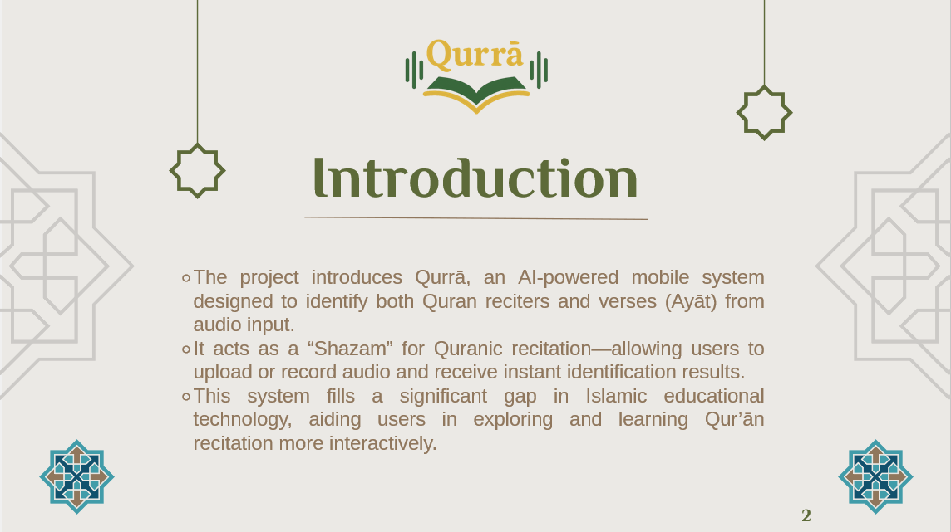
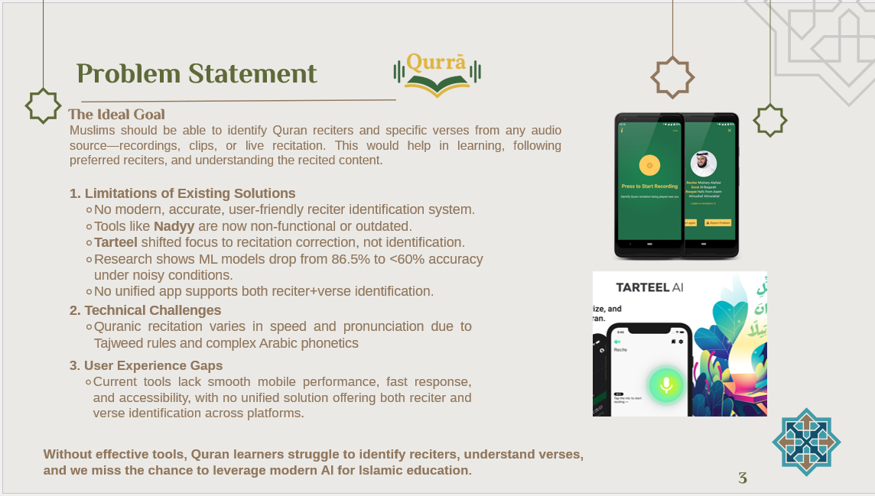
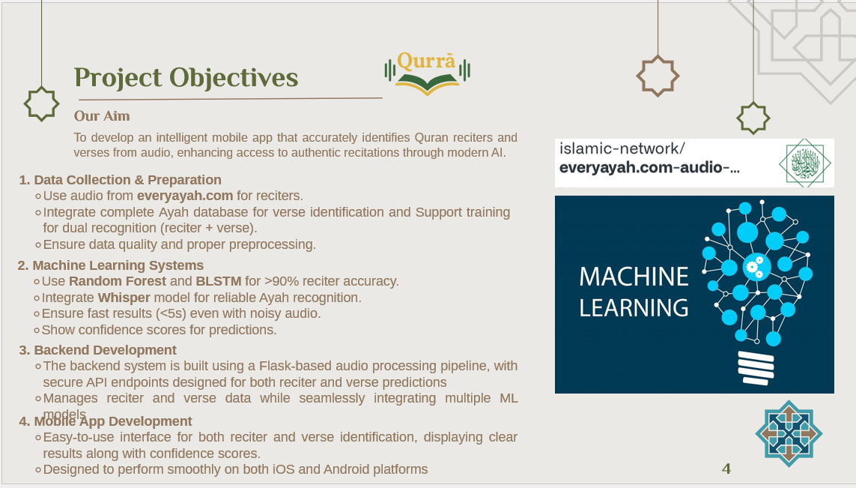
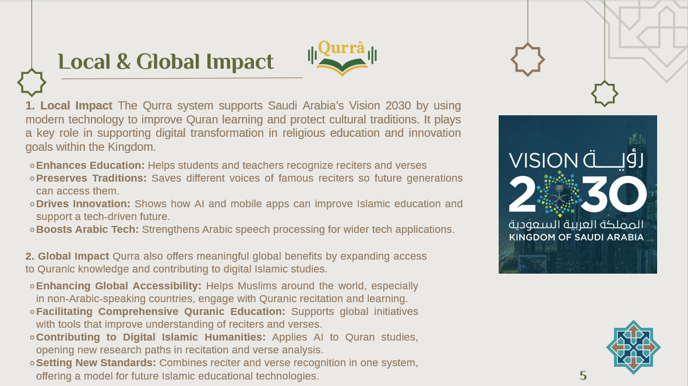
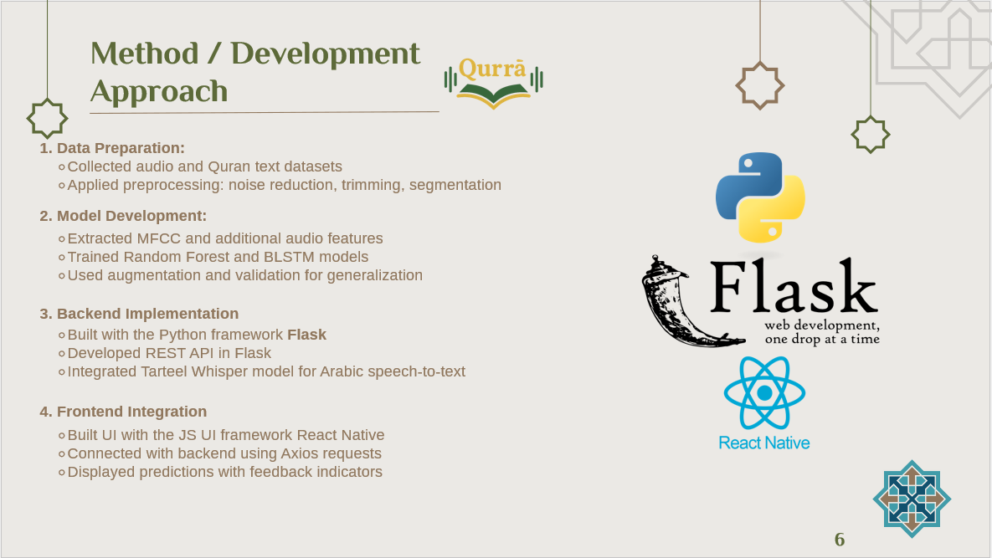
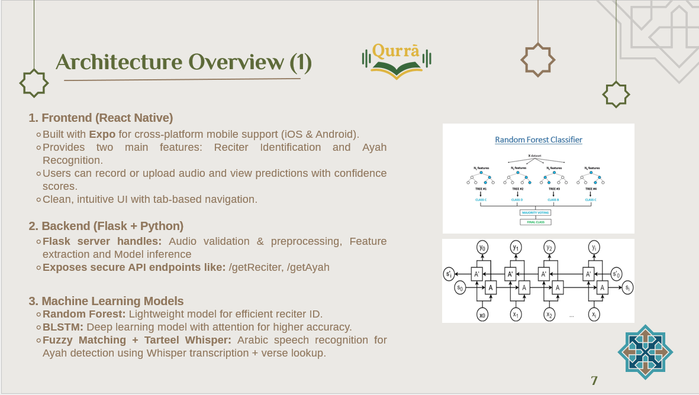
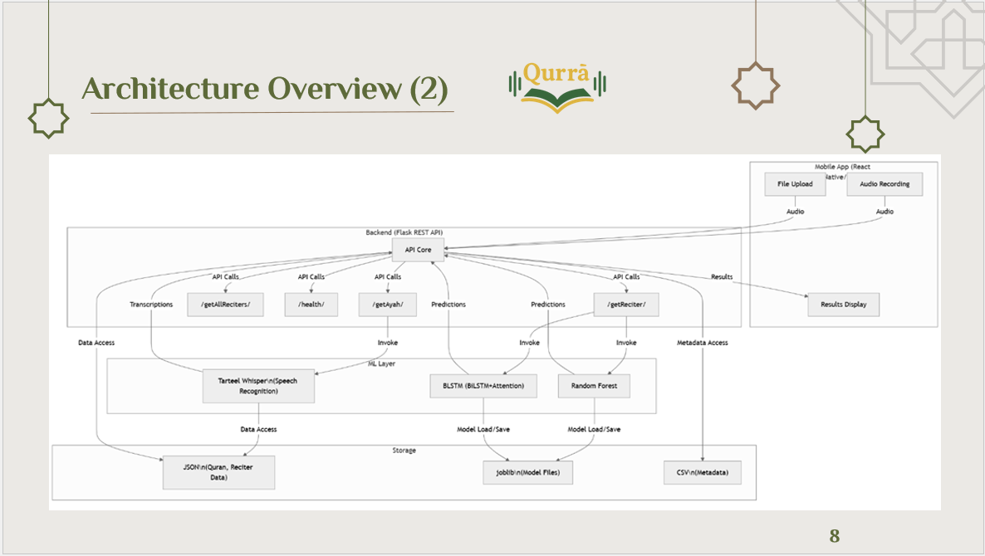
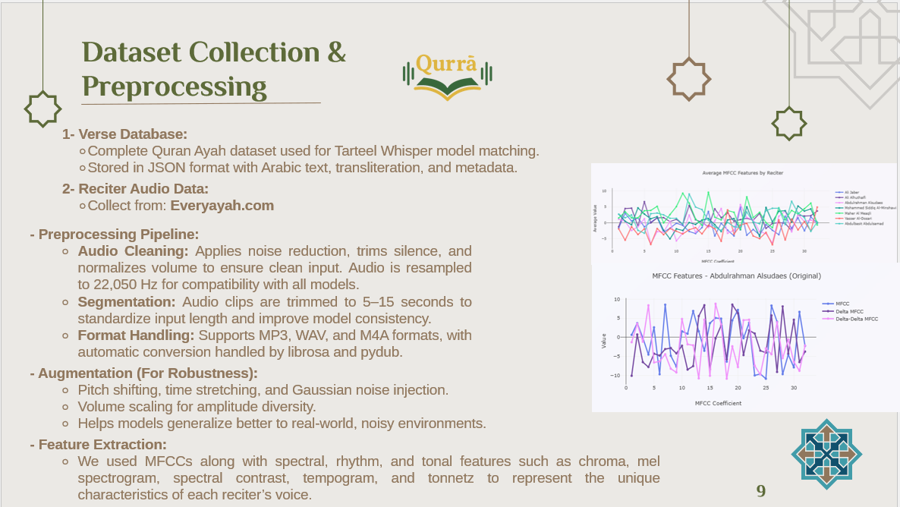
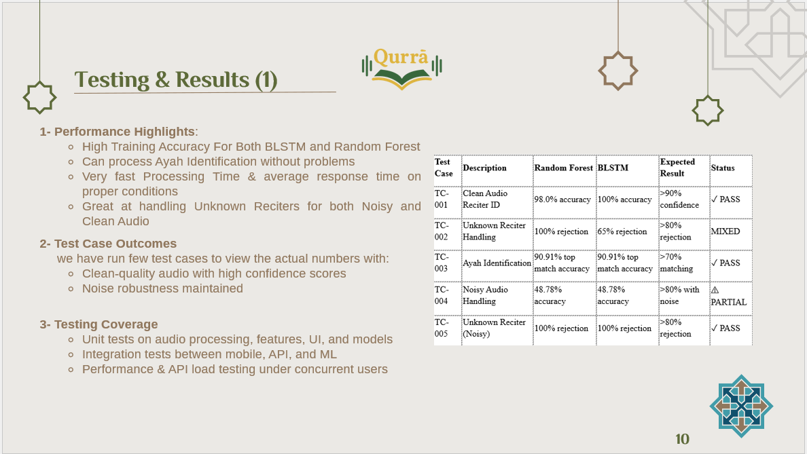
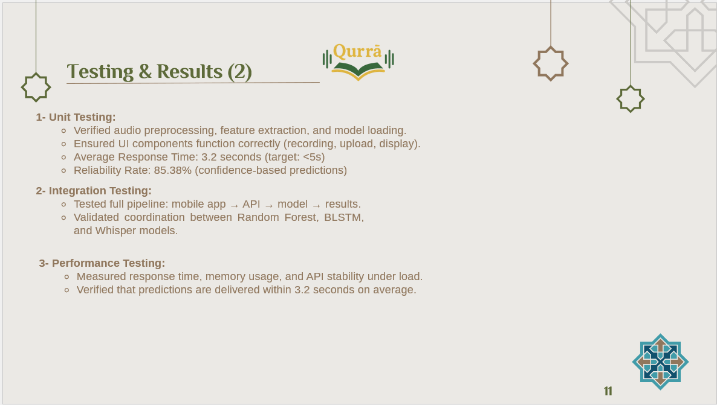
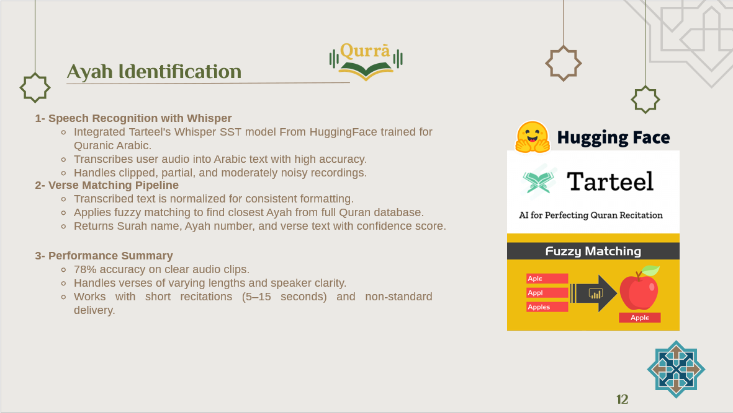
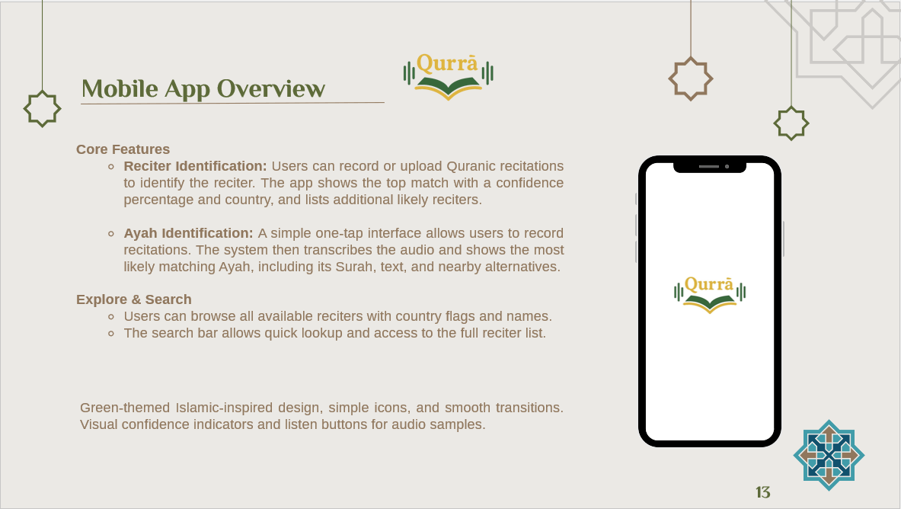
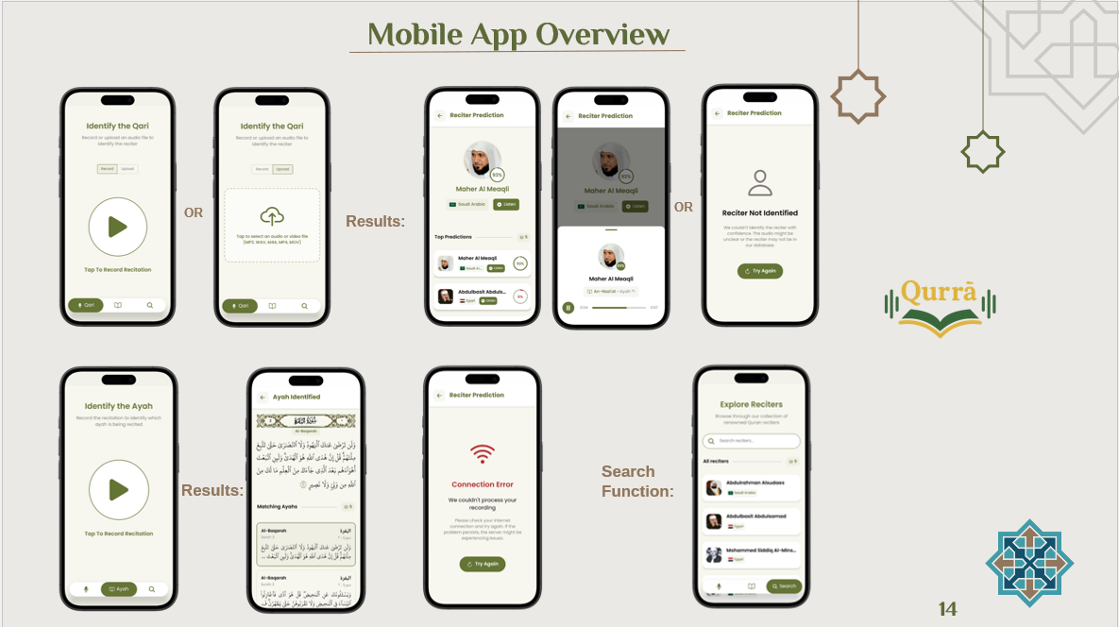
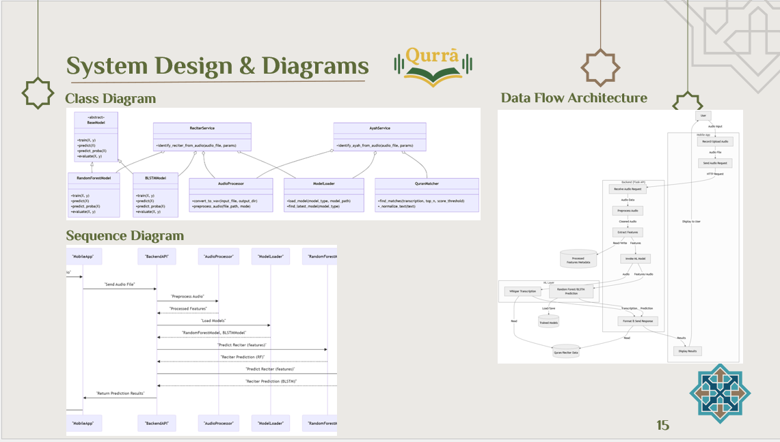
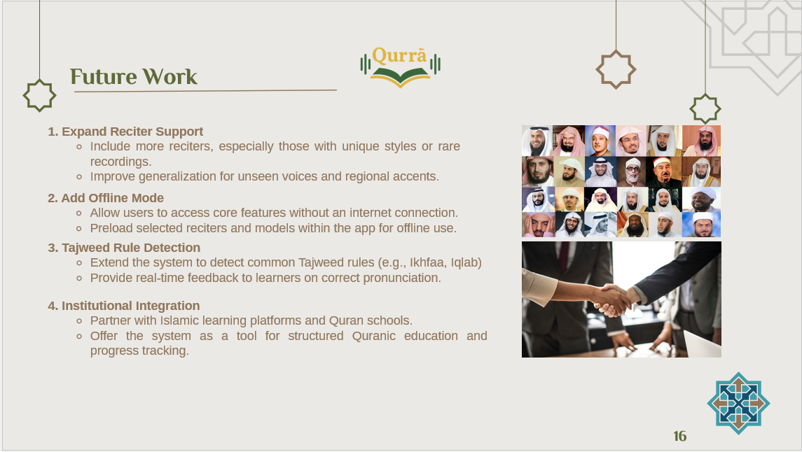
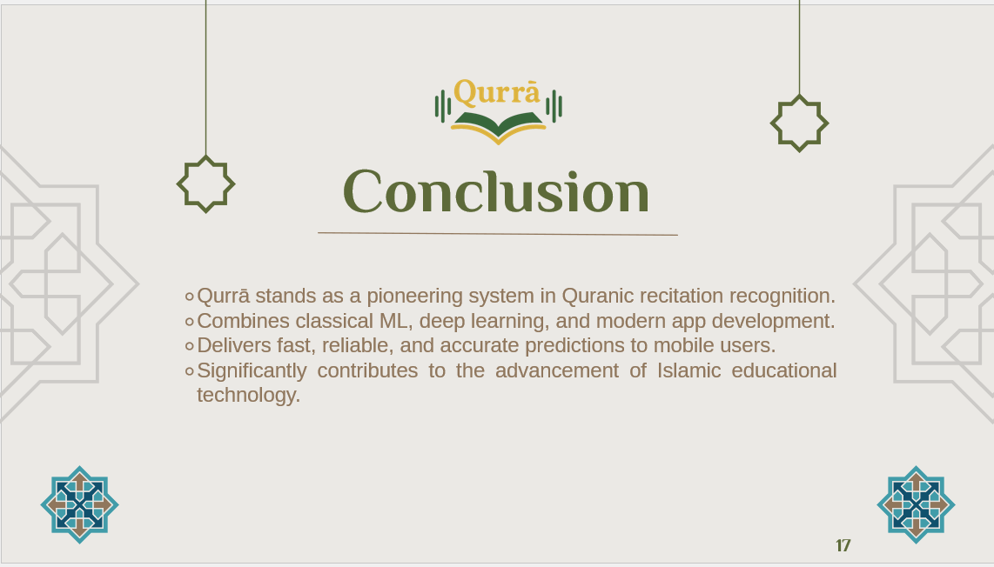
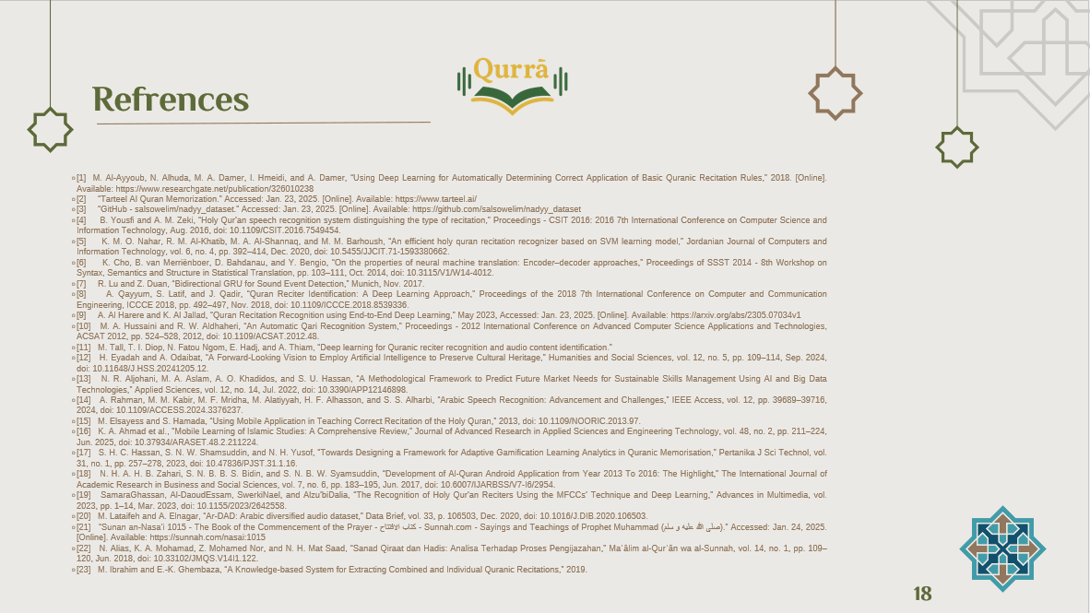


C. Miscellaneous
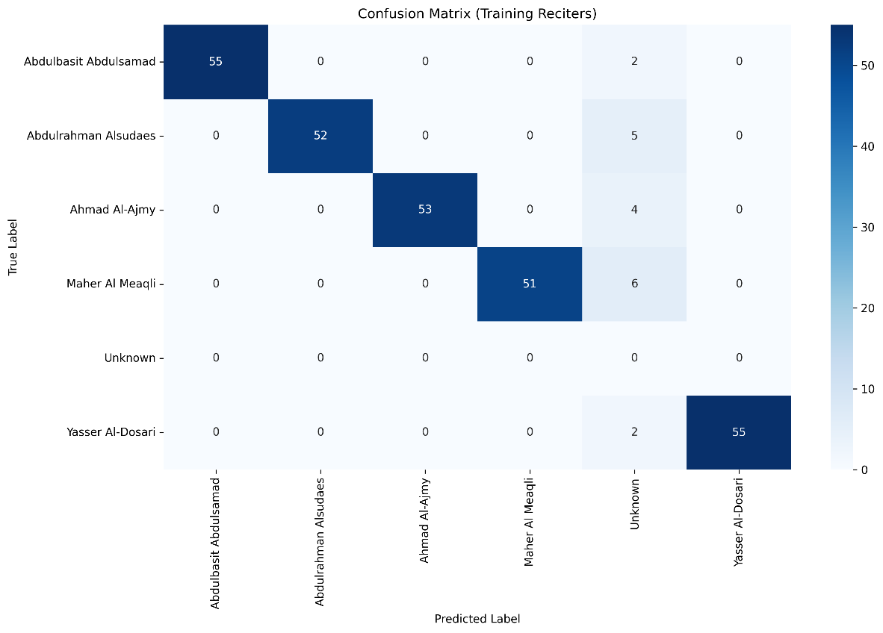
Confusion Matrix for extra test runs on the Random Forest Model

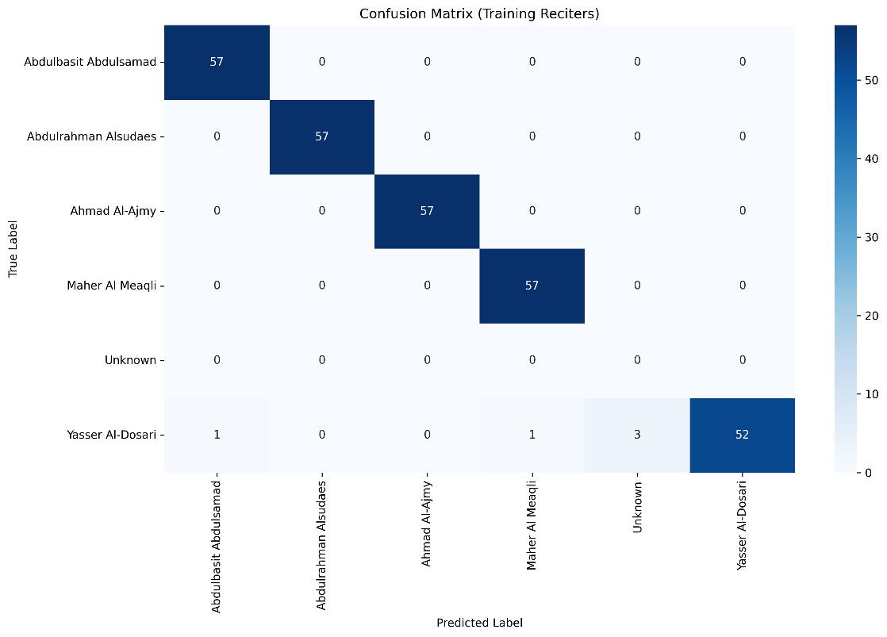
Confusion Matrix for extra test runs on the BLSTM Model

D. Meetings
Weekly Meeting Form

General Information
Project Title | Qurrā – An AI-Powered Quran Reciter and Verse Identification System
Group No. |  | Meeting No. | 1
Date | 2025/3/15 | Time | 8 pm

Attending Students
Student Name |  | ID | Signature
1 | Abdusamii Abdulazeez | 443022312 | 
2 | Ziyad Abdulaziz Algufari | 444003779 | 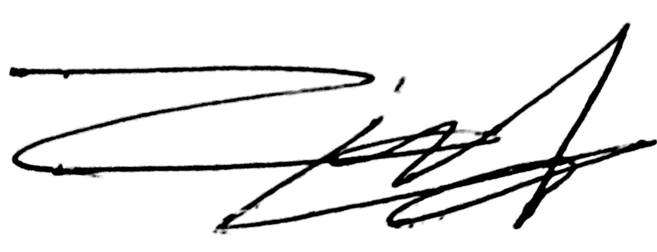
3

Discussed Topics and List of Accomplished Tasks
- Project initiation and scope definition
- Literature review planning and resource identification
- Initial dataset exploration from mp3quran.net
- Project timeline establishment and milestone planning
- Team role assignments and responsibility distribution
- Development environment setup (Python, libraries, React Native)
- Initial research on MFCC feature extraction techniques
- Review of existing Quran reciter identification solutions

Upcoming Tasks | Responsibility
Complete comprehensive literature review Analyze existing solutions (Tarteel, Nadyy) Begin dataset collection and organization | Ziyad Abdulaziz Algufari

Supervisor Name | Dr. Mohd Fazil
Signature | 

Information Technology Department
Weekly Meeting Form

General Information
Project Title | Qurrā – An AI-Powered Quran Reciter and Verse Identification System
Group No. |  | Meeting No. | 2
Date | 2025/4/13 | Time | 8 pm

Attending Students
Student Name |  | ID | Signature
1 | Abdusamii Abdulazeez | 443022312
2 | Ziyad Abdulaziz Algufari | 444003779
3

Discussed Topics and List of Accomplished Tasks
- Completed literature review on Quran reciter identification
- Successfully collected initial dataset from mp3quran.net
- Established development environment with required libraries
- Researched traditional ML approaches (SVM, Random Forest)
- Analyzed deep learning approaches (CNN, BLSTM)
- Defined system requirements (functional and non-functional)
- Created initial project structure and file organization

Upcoming Tasks | Responsibility
Complete comprehensive literature review Research MFCC and audio processing techniques | Abdusamii Abdulazeez
Setup development environment and tools | Both team members

Supervisor Name | Dr. Mohd Fazil
Signature

Information Technology Department
Weekly Meeting Form

General Information
Project Title | Qurrā – An AI-Powered Quran Reciter and Verse Identification System
Group No. |  | Meeting No. | 3
Date | 2025/4/20 | Time | 9 pm

Attending Students
Student Name |  | ID | Signature
1 | Abdusamii Abdulazeez | 443022312
2 | Ziyad Abdulaziz Algufari | 444003779
3

Discussed Topics and List of Accomplished Tasks
- Implemented data preprocessing pipeline successfully
- Completed MFCC feature extraction implementation
- Developed system architecture and class diagrams
- Started Random Forest classifier implementation
- Expanded dataset with data augmentation techniques
- Created database design and data dictionary
- Established audio processing parameters and configurations
- Implemented noise reduction and audio normalization

Upcoming Tasks | Responsibility
Begin data preprocessing pipeline development Continue dataset expansion and cleaning | Abdusamii Abdulazeez
Design system architecture diagrams Continue dataset expansion and cleaning | Ziyad Abdulaziz Algufari
Start Random Forest model implementation | Both team members

Supervisor Name | Dr. Mohd Fazil
Signature

Information Technology Department
Weekly Meeting Form

General Information
Project Title | Qurrā – An AI-Powered Quran Reciter and Verse Identification System
Group No. |  | Meeting No. | 4
Date | 2025/4/27 | Time | 8 pm

Attending Students
Student Name |  | ID | Signature
1 | Abdusamii Abdulazeez | 443022312
2 | Ziyad Abdulaziz Algufari | 444003779
3

Discussed Topics and List of Accomplished Tasks
- Successfully trained Random Forest model with >90% accuracy
- Implemented comprehensive model evaluation metrics
- Developed backend API
- Optimized feature extraction for mobile deployment
- Created confusion matrix and performance visualizations
- Implemented cross-validation and model validation
- Established distance-based reliability analysis

Upcoming Tasks | Responsibility
Create confusion matrix visualization Implement model evaluation metrics | Ziyad Abdulaziz Algufari
Complete Random Forest model training Begin backend API development | Abdusamii Abdulazeez
Optimize feature extraction pipeline | Both team members

Supervisor Name | Dr. Mohd Fazil
Signature

Information Technology Department
Weekly Meeting Form

General Information
Project Title | Qurrā – An AI-Powered Quran Reciter and Verse Identification System
Group No. |  | Meeting No. | 5
Date | 2025/5/10 | Time | 7 pm

Attending Students
Student Name |  | ID | Signature
1 | Abdusamii Abdulazeez | 443022312
2 | Ziyad Abdulaziz Algufari | 444003779
3

Discussed Topics and List of Accomplished Tasks
- Developed React Native mobile application framework
- Implemented BLSTM model with attention mechanism
- Successfully integrated backend APIs with mobile frontend
- Created intuitive user interface with audio recording capability
- Implemented prediction confidence scoring and reliability analysis
- Added real-time audio processing and file upload features
- Integrated both Random Forest and BLSTM models
- Completed API authentication

Upcoming Tasks | Responsibility
Conduct comprehensive system testing Optimize mobile app performance Implement user acceptance testing | Ziyad Abdulaziz Algufari
Prepare deployment configuration Fine-tune model accuracy and reliability | Abdusamii Abdulazeez

Supervisor Name | Dr. Mohd Fazil
Signature

Information Technology Department
Weekly Meeting Form

General Information
Project Title | Qurrā – An AI-Powered Quran Reciter and Verse Identification System
Group No. |  | Meeting No. | 6
Date | 2025/5/24 | Time | 8 pm

Attending Students
Student Name |  | ID | Signature
1 | Abdusamii Abdulazeez | 443022312
2 | Ziyad Abdulaziz Algufari | 444003779
3

Discussed Topics and List of Accomplished Tasks
- Completed comprehensive system testing (unit, integration, UAT)
- Successfully optimized mobile application performance
- Fine-tuned models achieving >90% accuracy target
- Prepared deployment configuration for cloud services
- Conducted extensive testing across different devices
- Implemented final UI/UX improvements based on testing

Upcoming Tasks | Responsibility
Deploy system to production environment Prepare final presentation and demo | Ziyad Abdulaziz Algufari
Submit project deliverables Conduct final system validation Finalize project documentation and report | Abdusamii Abdulazeez

Supervisor Name | Dr. Mohd Fazil
Signature

E. User Manual


